Network Camera User Manual(VCA)

2023-11-1.3 Version

Content
1. Instruction 3
2. Safety Precautions 3
3. Connector Instructions 3
4.1 Network Connecting Diagram 4
4.2.1 Browser Setting 4
4.2.2 Login Interface 4
4.3 Realtime Preview 7
4.5 Parameter Setting 9
4.5.1 Device Information 10
4.5.2 PTZ Setting 11
4.5.3 Time Setting 11
4.5.4 Audio Setting 13
4.5.5 Display Setting 14
4.5.6 Encoding setting 14
4.5.7 Image parameters 16
4.5.8 Setting of fill light 17
4.5.9 Privacy Masking 18
4.5.10 Motion detection 19
4.5.11 Occlusion alarm 20
4.5.12 Regional Intrusion 22
4.5.13 Line crossing detection 25
4.5.14 Loitering 28
4.5.15 Absence Detection 31
4.5.16 Vehicle illegal Parking 34
4.5.17 Vehicle Retrograde 36
4.5.18 Recording Configuration 39
4.5.19 Network Setting 39
4.5.20 RTMP Setting 42
4.5.21 Http(s)Push 43
4.5.22 Mobile monitoring 43
4.5.23 Platform management 44
4.5.24 Multicast configuration 45
4.5.25 Email Setting 45
4.5.26 FTP Setting 46
4.5.27 Alarm input 47
4.5.28 Alarm Output 47
4.5.29 User Management 48
4.5.30 System Upgrade 48
4.5.31 Equipment maintenance 49
4.5.32 Developer Options 50
1.1 Exit the system 50
2 Common troubleshooting 51

Instruction
This manual provides the necessary operation instructions for the correct usage of our IP camera. In view of the professional nature and powerful functions of the device, please read the user manual carefully before using the device. Trained professionals should strictly follow the operation procedures and precautions in the user manual to use and maintain the device. You are advised to keep the user manual and related documents together with the device for reference when necessary.

Safety Precautions

To prevent danger and prevent property damage, please read this instruction carefully and strictly observe it before use. If you are installing this equipment in a public place, please give notice of warning “in a prominent place: "You already entered monitoring area".
During the installation and use of the equipment, please strictly follow the installation requirements. The company will not be liable for any damage to the equipment that has not been installed in accordance with the installation requirements.
During installation and use of the equipment, strictly observe local electrical safety standards and use the power adapter marked with the LPS standard, otherwise it may cause damage to the machine.
Please use the accessories included with the product. The equipment supply voltage must meet the input voltage requirements of the equipment.
The equipment is installed in unstable voltage areas and needs to be grounded to release surges and other high energy to prevent the equipment from being burned out.
When using the device, do not allow water or any liquid to flow into the device. If liquid accidentally flows into the device, immediately disconnect the power and remove all cables (such as power cables and network cables) from the device.
Do not focus the device on strong light (such as lighting, sunlight, etc.), otherwise it may affect the life of the image sensor. The equipment is installed in areas where there is frequent lightning, and it needs to be grounded nearby to release high energy such as lightning and prevent equipment damage.
During transportation and storage, heavy pressure, severe vibrations, and soaking are required to prevent damage to the product.
Do not drop the device on the floor or be strongly knocked, and keep the device away from places where magnetic interference exists, and avoid installing the device on a surface that is subject to shock or shock.
Please use a soft, dry cloth to clean the body. If dirt is difficult to remove, wipe it off with a dry cloth, and gently wipe it with a small amount of neutral detergent. Then wipe it dry.
Do not block the vents. When installing the device, pay attention to the manufacturer's installation instructions.
Do not place the machine near heat sources such as radiators, heaters, or other heat-generating equipment.
Please do not place the machine in humid, dusty, hot, cold, strong electromagnetic radiation and other places.
When the equipment is installed outdoors, please be sure to take measures against insects and moisture to avoid corrosion of the circuit board and affect monitoring.
If you do not use it for a long period of time, unplug the device.

Special Notes:
The whole product that our company sells, after passing our strict inspection, after the inspection is ex-factory, the product is accompanied with the nameplate, the quick operation manual and the attachment and so on.
All products that are not manufactured or counterfeited by our company are not responsible for all the resulting liabilities.
Our company will update the content of this manual according to the enhancement or change of product features, and will regularly improve and update the hardware and software products described in this manual. The updated content will be added in the new version of this manual without notice.
This manual may contain technical inaccuracies, or inconsistencies with product features and operations, or typographical errors, which are subject to the company's final interpretation.
The content of this manual is for users only, it does not guarantee that it is completely consistent with the actual object. Please prevail in kind.

Connector Instructions

1、Power port：DC12V
2、Audio Input：MIC Port（MIC IN）（G.711U compression standard）
3、Audio Output：Audio output signal（AUDIO）（G.711U compression standard）
4、Network Port：Support ONVIF 2.0 protocol, Ethernet（RJ45，10/100M), support TCP/IP、UDP、HTTP、RTSP protocol IE, POE, video code format is H.265

4.Function Usage Instructions

4.1 Network Connecting Diagram
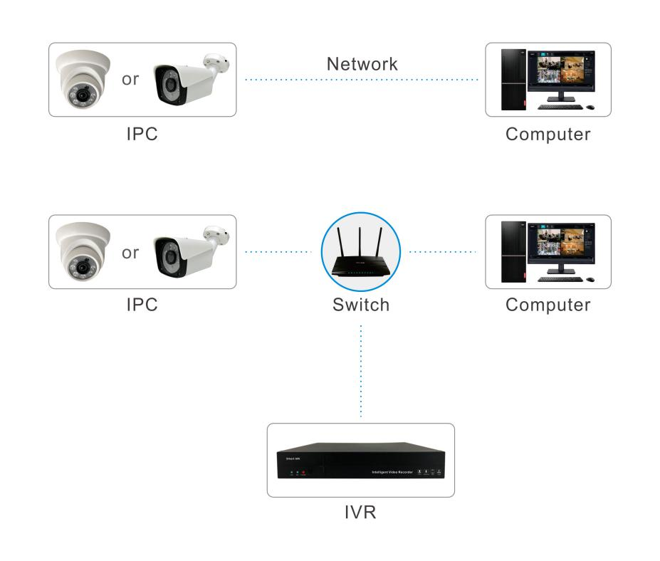
There are two kinds of connection between IP camera and computer, connect ipc to computer directly trhough RJ45 network cable, or connect IPC to computer through switch, refer to following picture:

Note：
- IPC default IP address is“192.168.1.188”, Port is“80”, user name:“admin”;
- IPC gateway must be the same with computer gateway;

4.2 Network Visiting Configuration

Browser Setting
After finish hardware installation, it is necessary to preview camera parameters and set the relevant parameters. The following describes the relevant configuration of entering control interface through IE browser.

Login Interface
User Inputs device Ip address in Google browser(default IP address is 192.168.1.188 )to enter login interface
When user login at the first time, user needs to install plugin, to click hint to download plugin and install ActiveX control software, refer to following picture.
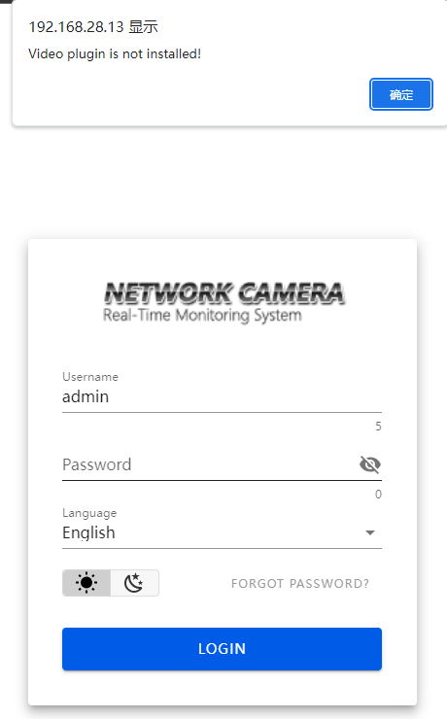
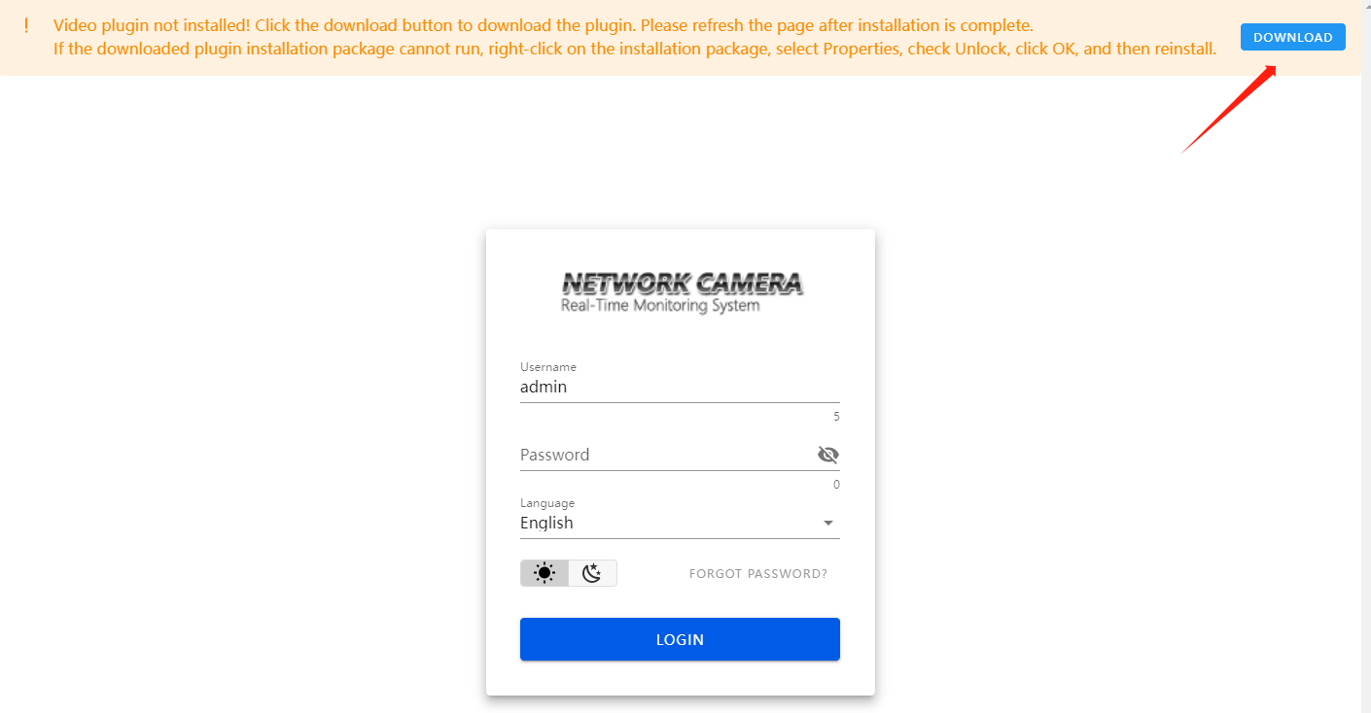
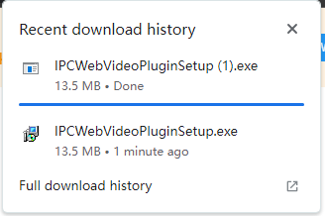

After finishing installing it, default user name is admin, password is 123456
If user need to change default password, click” forget password” button, it will pop up interface of password setting, user can set password at will,please refer to following picture

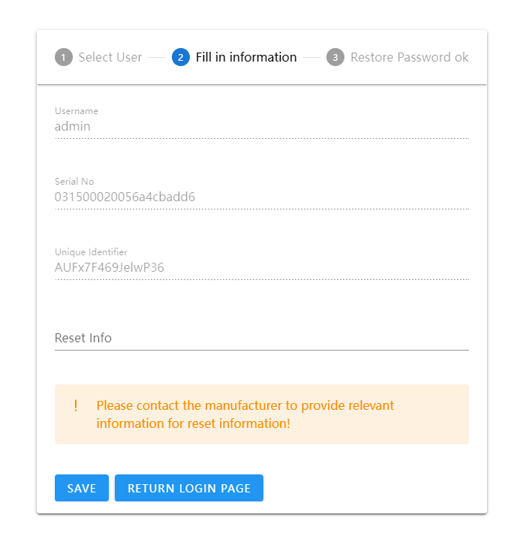
After finishing setup new password, user can login landing interface, refer to following picture:
User name：admin（default）
Language: choose Chinese or English, then login.
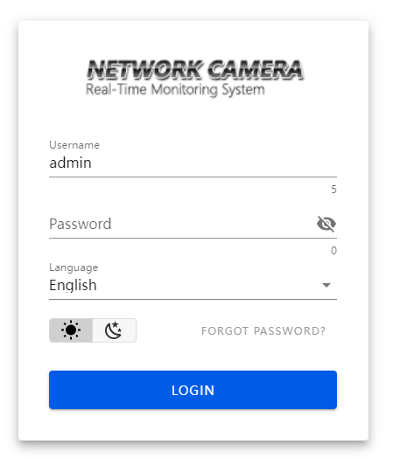

4.3 Realtime Preview
After login interface, user can go to preview interface, refer to following picture:
Note: Device with TF card is full function display interface, otherwise it is simplicity display interface
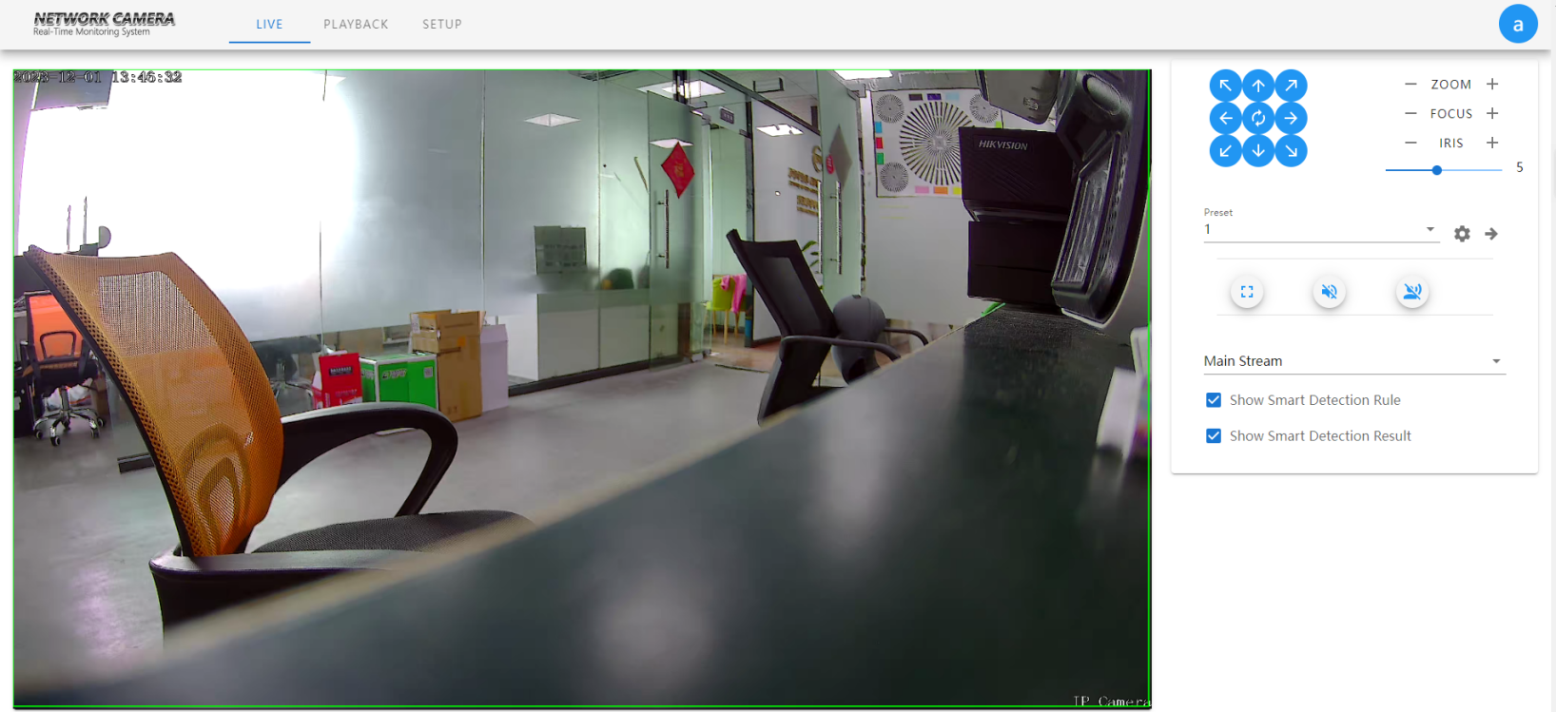
P/T Control：Click right iconto control PTZ moving direction
Zoom/Focus/IR：click by mouse“-”“+” icon to control zoom and focus effect
Speed：Value would be set1-5, default parameter display 5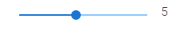

Preset：Preset can choose 1-255 parameter,user can set preset parameter to call preset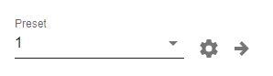
Preview in full screen: to click full screen icon  or click mouse right key one time on preview window, click mouse right key one time on preview window or click ESC on keyboard to exit full screen mode.

- Full Screen：Display current preview in full screen 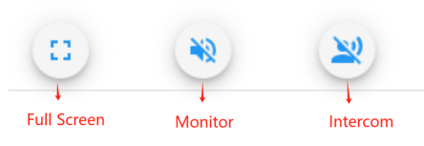
- Monitor：Enable/Disable monitor
- Intercom：Enable/Disable
（Note：Blue X would be disable or not allow ）
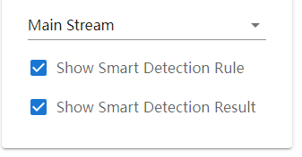
- Main stream：choose main stream preview or sub-stream preview.
- Display Intelligent Detection Rules:Display intelligent frame on preview page
- Display intelligent Detection Result:Dsiplay intelligent detection frame on preview page, line is blue.

4.4 Playback

The following picture is playback interface:
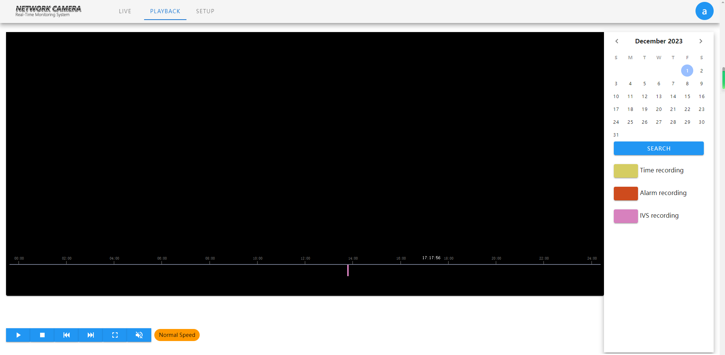

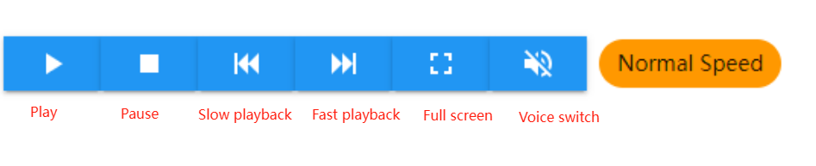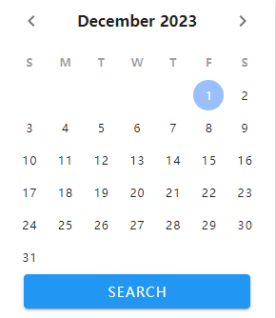
      - Search Recording：Fist choose date, click search icon to search recording file
      - Play：Click play icon
      - Pause：Click pause icon,recording play would be paused
      - Stop：Click stop icon, recording would be stop immediately
      - Slow Playback: Support2/4/8/16X slow playback
      - Fast Playback: Support2/4/8/16X fast playback
      - Full Screen: mouse left key to click fullscreen incon, preview window would be full screen
      - Sound Switch:Enable sound when play recording
      - Normal Speed: Display current times value

(The timing recording search color is yellow, the alarm recording detection color is red, and the intelligent detection recording is rose red)

4.5 Parameter Setting

The following picture is configuration interface,the list on the left shows various parameter configuration modules. The configuration information of each module is different,explain in turn below:

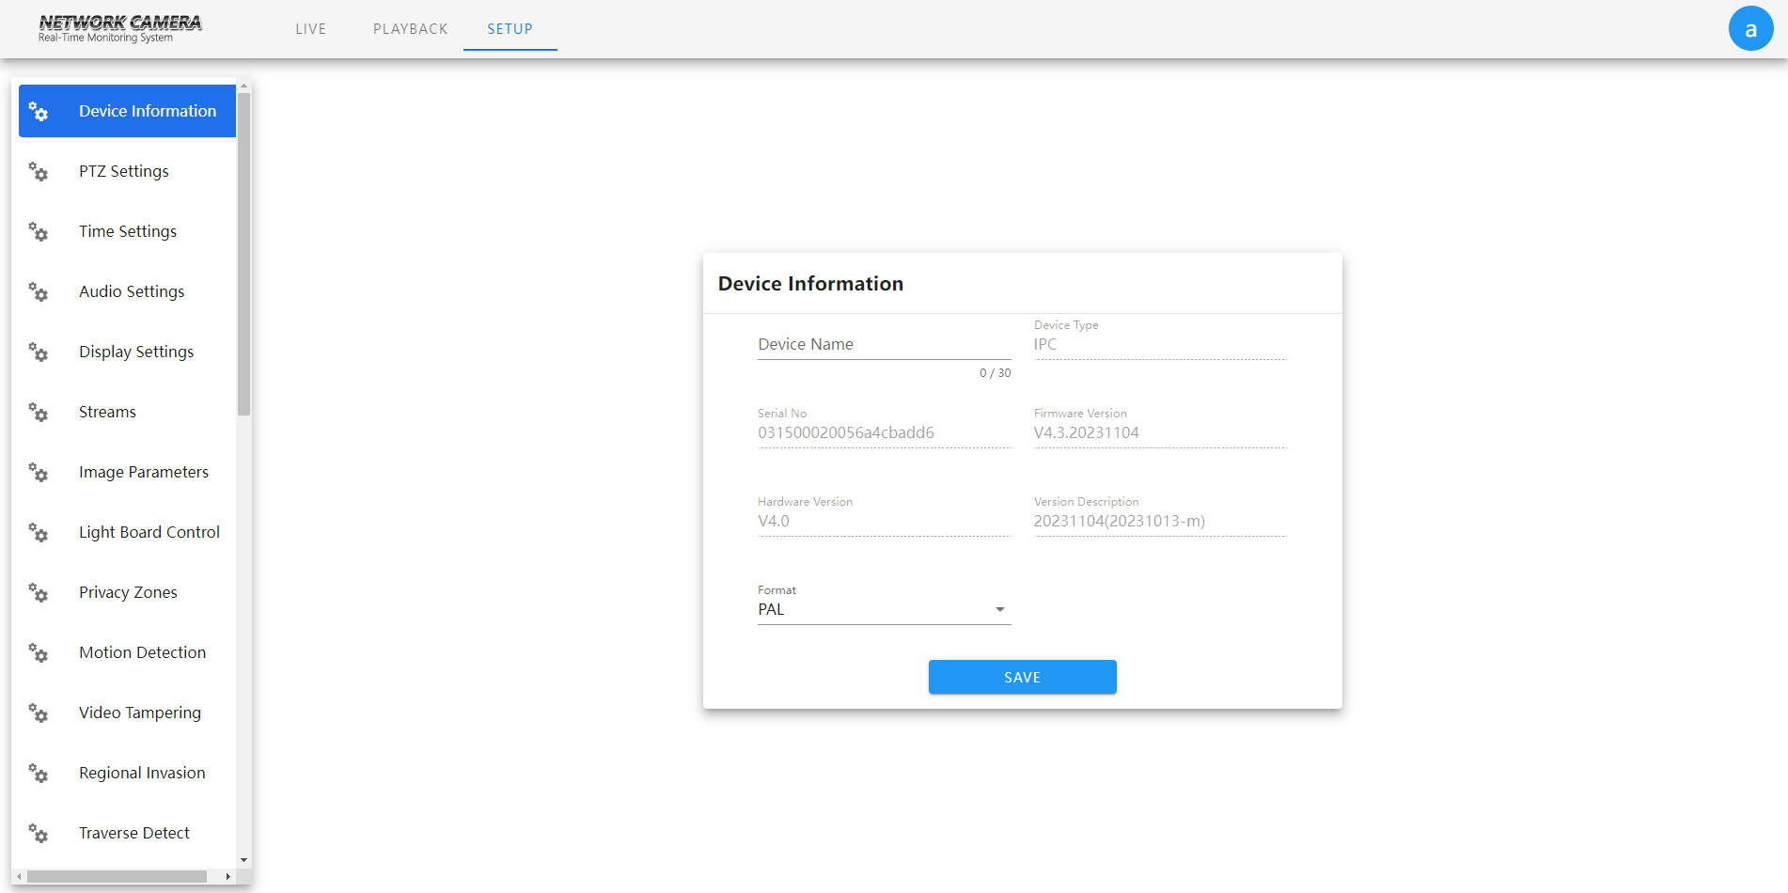

4.5.1 Device Information

IP Camera device information page as following:
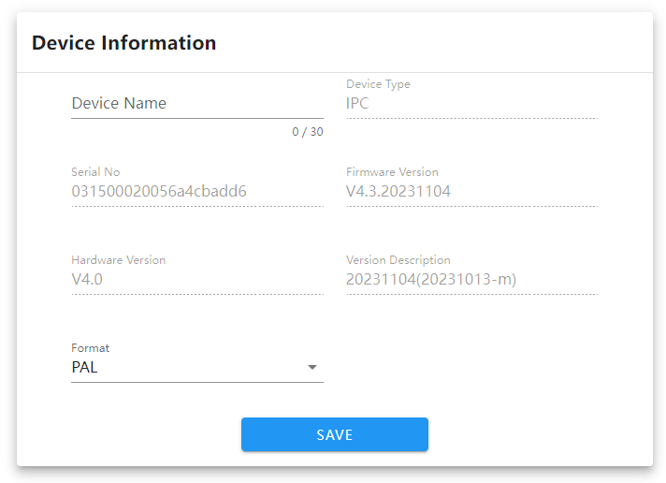

      - Device name：user can set device name
      - Device type：display device style, do not allow to modify
      - Series number：display series number,do not allow to modify.
      - CPU version：display software version date, does not allow to modify
      - Hardware version：display hardware version, does not allow to modify
      - Version description: display version firmware time
      - System：PAL and NTSC
After finish setting parameters, clieck “save” , then setting would be valid

4.5.2 PTZ Setting

IP Camera’PTZ setting interface as follows:

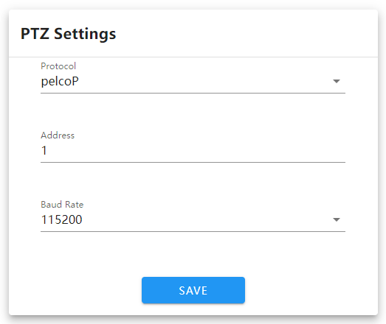

      - Protocol：Support pelcoP and pelcoD
      - Address：default 1,can change it according to requirement
      - Baud rate: Support 15 kinds of baud rate
After finish setting, clieck”save”, then setting would be valid

4.5.3 Time Setting

IP Camera’s time setting interface as follows:
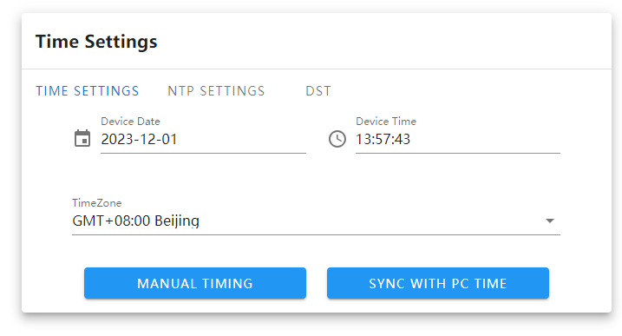
It is mainly divided into three parts: time setting, NTP setting, daylight saving time
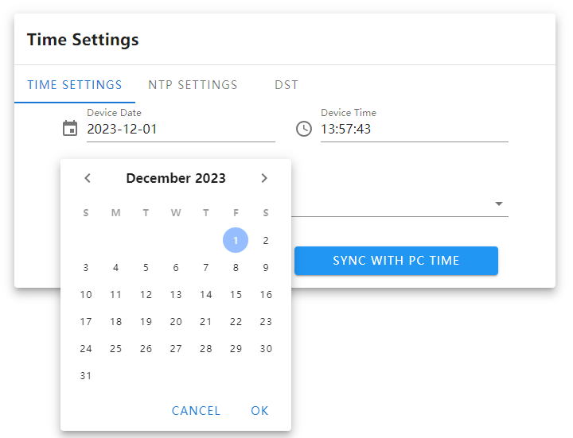
NTP：device time choose time, click”NTP” firstly, then save it
      - PC ：If user want to keep time same with PC time (local PC), click【PC】firstly, then save it.

IP Camera’s NTP setting interface as follows:
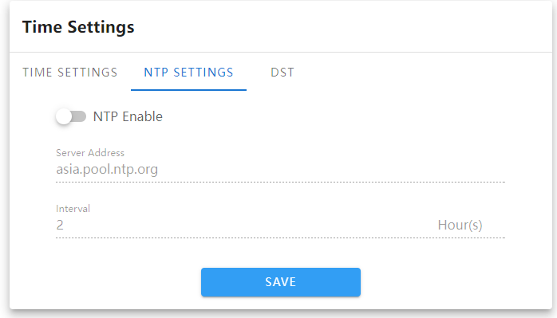
Choose NTP, fill server, adjust interval time according to requirement, then click “save”
Note：after enable NTP, time setting content would be invalid
IP Camera’s daylight saving time setting interface as follows:
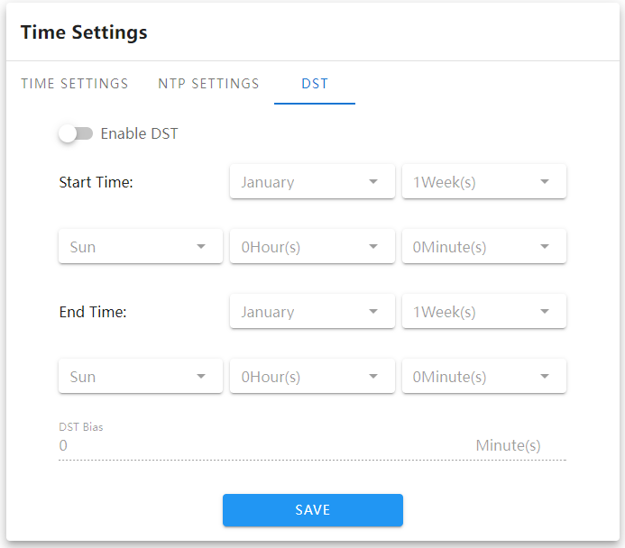

      - Enable daylight saving time：to enable or disable this function,if it is in the area of daylight saving time,click 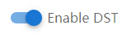to enable it, then it is ok.

      - Start time of daylight saving time: set start time

      - End time of daylight saving time: set end time

      - Offset time：Set daylight saving time offset time,threshold value is 0-720 minutes。
After finish setting parameters, to click “save”, then setting would be valid.

4.5.4 Audio Setting

The audio setting interface of IP Camera is shown in the following figure:
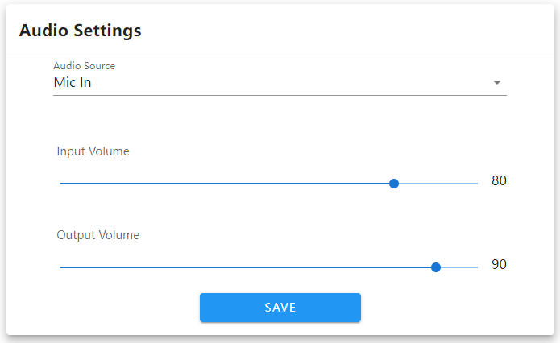
      - Audio source: select the audio input method, with two modes to choose from: line in and microphone input.

      - Input volume: set the size of the input volume, with a range of 0-100 and a default of 90.

      - Output volume: set the size of the input volume, with a range of 0-100 and a default of 60.

After setting the parameters, click the [Save] button and the settings will take effect.

4.5.5 Display Setting
The display setting interface of IP Camera is shown in the following figure:
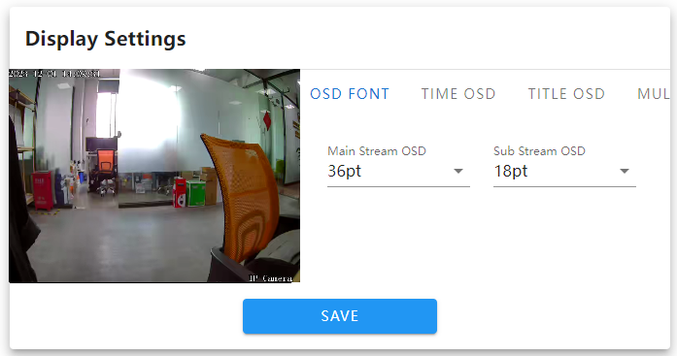

      - OSD font: change the font theme.

      - Time OSD: select different time/date formats.

      - Title OSD: name modification for IPC.

      - Multi line OSD: multiple line OSD information can be set arbitrarily.

      - Chroma: adjust the brightness, color, and contrast of the image.
      - Title position/date adjustment/multi line adjustment: Move the title and date display on the preview screen in real time by clicking on these four controls, as well as "top left corner", "top right corner", "bottom left corner", and "bottom right corner".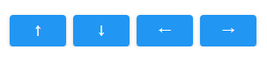
After setting the parameters, click the [Save] button and the settings will take effect.

4.5.6 Encoding Setting

The encoding setting interface of IP Camera is shown in the following figure:
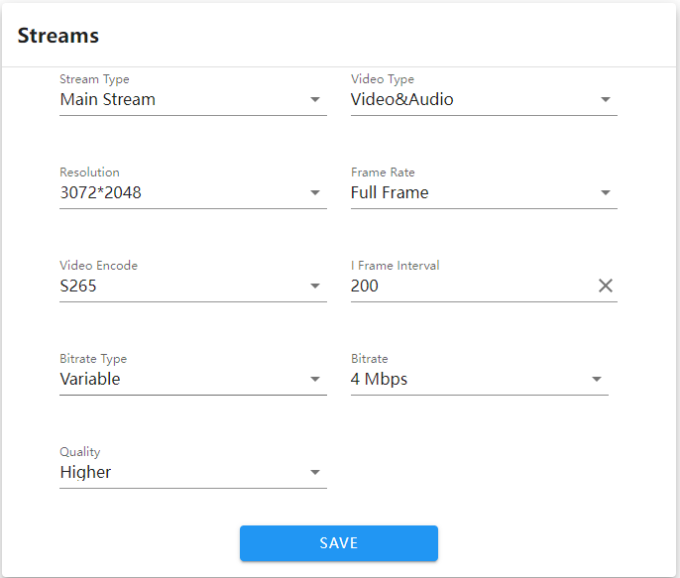

      - Stream compression types: main stream (timing) and sub stream (network transmission).

      - Stream types: including composite streams and video streams.

      - Resolution: display the resolution of the network video stream of this camera.

      - Video frame rate: fps: 1~25/30. In the device information format, you can switch between P/N mode, with a full frame rate of P=25 fps or N=30 fps.

      - Encoding types: including H264/H265/S265.
      - I-frame interval: the interval size of I-frames can be set, with a default of 50.

      - Bit rate types: including fixed rate and variable rate.

      - Bit rate: different bit rates can be set according to needs (note: the default bit rate from the factory shall prevail). After setting the parameters, click the [Save] button and the settings will take effect.

4.5.7 Image Parameters

The image parameters setting interface of IP Camera is shown in the following figure:
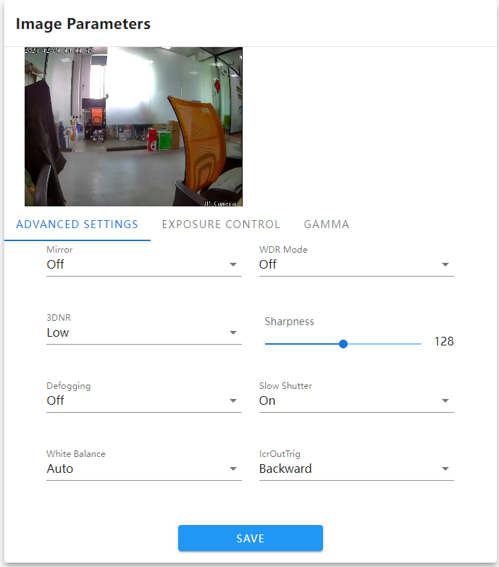
      - Mirror: there are four options available: Close, Horizontal Mirror, Vertical Mirror, and 180 Rotate. The default mode is off, and this option takes effect immediately upon setting. It is saved non volatile.
      - Wide Dynamic: there are two options: Off and Digital Wide Dynamic, with the default being Off.
      - 3D Time Domain: there are four gear options available: off, low, medium, high, and high. The 3D Time Domain defaults to the low gear.
      - Sharpness: the value is adjustable from 0 to 255. The default sharpness value is 128.
      - Defog function: available in off, low, medium, and high modes, default off.
      - Night frame reduction: available on/off, default off.
      - White Balance: there are seven modes available: automatic, user-defined, locked white balance, incandescent light, warm light, natural light, and fluorescent light.
      - IR-cut: there are two modes: forward and reverse.
      - Backlight mode: off, strong light suppression, backlight compensation, default off.
      - Backlight level: the default value is 5, and the threshold range is 1-10. The value can be adjusted according to customer needs.
      - Target brightness: the default value is 50, and the threshold range is 1-100. The value can be adjusted according to customer needs.
      - Exposure allocation strategy: there are two modes: gain priority and exposure priority.
      - Gain control: this function can only be set during automatic exposure, divided into low, low, medium, high, and high. The automatic gain value defaults to a higher value. The higher the automatic gain value, the higher the sensitivity under low illumination, but the noise will also be more pronounced.
      - Shutter: this function can only be set during manual exposure, with a shutter value range of 1/5-1/100000.
      - Gamma: divided into CURVE_ 1_ 6. CURVE_ 1_ 8. CURVE_ 2_ 0, CURVE_ 2_ Two four modes, Gamma defaults to
CURVE_ 2_ 0
      - Power frequency: three modes: off, 50Hz, 60Hz. The default is off.
After setting the parameters, click the [Save] button and the settings will take effect.

4.5.8 Setting of Light Board

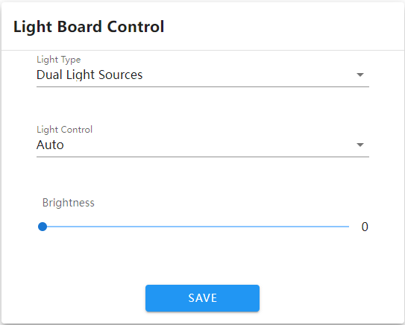
      - Lighting mode: divided into three modes: infrared light, warmlight, and dual light, with dual light displayed by default.
      - Light control: divided into five modes: normally closed, normally open, automatic, timed, and external trigger, with default automatic.
      - Normally closed: the light panel is always closed, and the light panel is uncontrollable.
      - Normally open: forcefully adjust the brightness of the light panel, with a range of 1-100. The larger the parameter value, the brighter the infrared light.
      - Automatic mode: the camera dynamically adjusts the brightness of the light panel by obtaining the current image brightness, exposure, and gain, to achieve the optimal image and minimize power.
      - Timing: switch lights according to the set time.
      - External trigger: connect to the photosensitive resistor light board and select the external trigger mode.
      - Brightness: when the light panel control mode is manual, the brightness of the light panel can be controlled, with a range of 0-100.

4.5.9 Privacy Mask

The privacy mask setting interface of IP Camera is shown in the following figure:
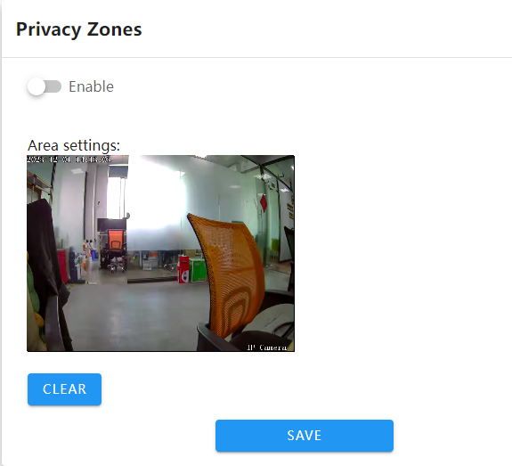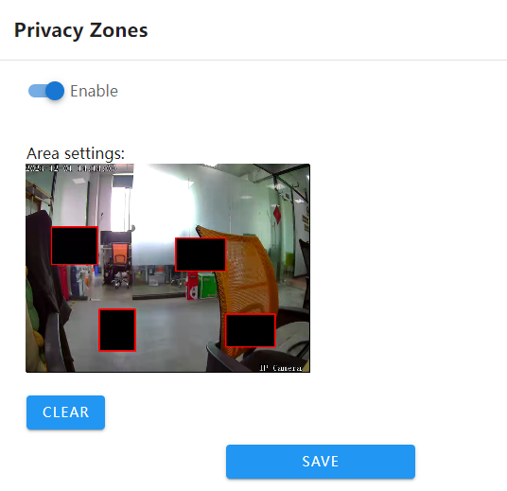

      - Enable: privacy mask function can be enabled or disabled

      - Set Area: in the preview interface of the "Set Area", hold down the left mouse button and drag to select the area to be masked, and draw up to 4 private areas.
      - Clear: click [Clear] to clear the area specified by IPC. After setting the parameters, click the [Save] button to make the settings effective.

4.5.10 Motion Detection

The motion detection alarm setting interface of IP Camera is shown in the following figure:
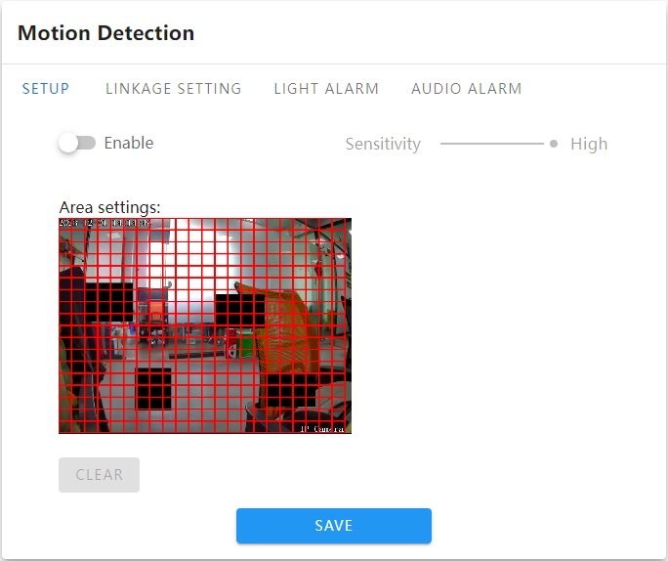

      - Enable: set whether to enable detection function.
      - Sensitivity: the higher the sensitivity, the more pronounced the effect of detecting movement.
      - Start drawing: in the preview interface of the "Settings Area", hold down the left mouse button and drag to draw a circle and select the area to be detected.
      - Clear: click [Clear] to clear the area specified by IPC.
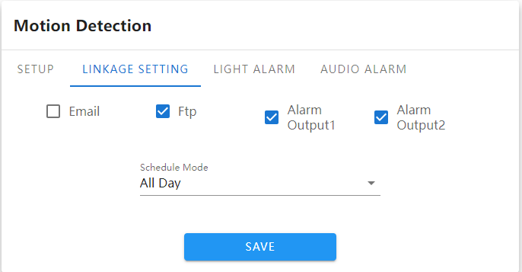
Linkage settings:
      - Upload email: select to enable or disable the alarm linkage function.
      - FTP: enable the function to capture and push a picture to the FTP server at the beginning and end of the alarm.
      - Alarm output 1: enable or disable alarm linkage alarm output 1.
      - Alarm output 2: enable or disable alarm linkage alarm output 2.
      - Deployment mode: divided into full day deployment, night deployment, and custom deployment, set as needed.
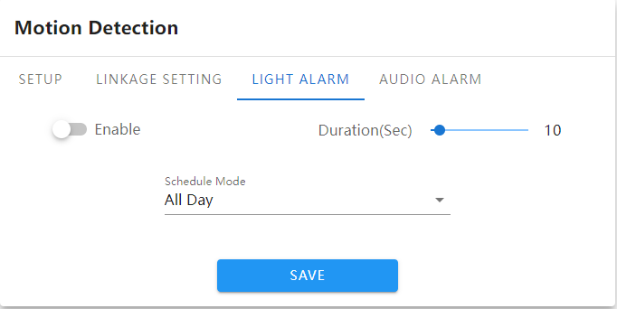
      - Enable: the alarm indicator light can be set to prompt after triggering.
      - Alarm duration: the parameter can be selected from 1 to 100, and the default display parameter is 10.
      - Deployment mode: divided into full day deployment, night deployment, and custom deployment, set as needed.
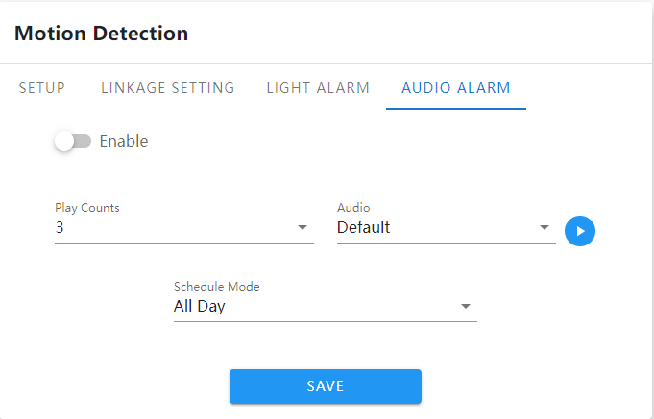
      - Enable: it can enable the triggering of motion alarms to generate alarm related prompt sounds.
      - Playback count: selectable from 1 to 10 and looping, default display is 3 times.
      - Audio: when an alarm is triggered, the alarm prompt sound will sound. Click the play button to try listening to the alarm voice.
      - Deployment mode: divided into full day deployment, night deployment, and custom deployment, set as needed.
After setting the parameters, click the [Save] button and the settings will take effect.

4.5.11 Occlusion Alarm

The occlusion alarm setting interface of IP Camera is shown in the following figure:
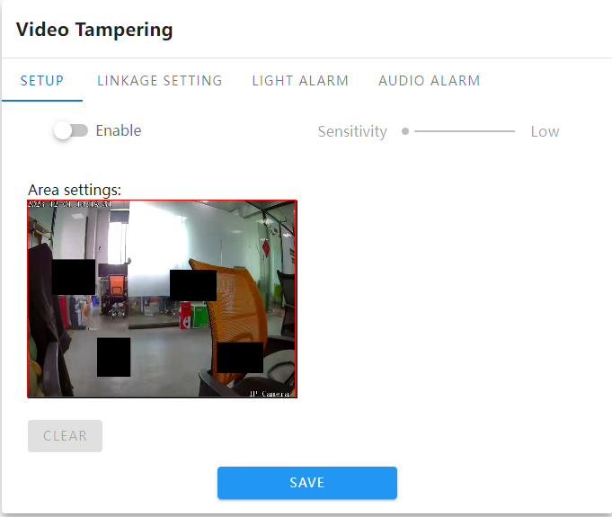
      - Enable: set whether to enable the occlusion alarm function.
      - Sensitivity: the higher the sensitivity, the easier it is to trigger occlusion alarms.
      - Start drawing: in the preview interface of the "Set Area", hold down the left mouse button and drag to set the area to be obscured.
      - Clear: click [Clear] to clear the area specified by IPC.
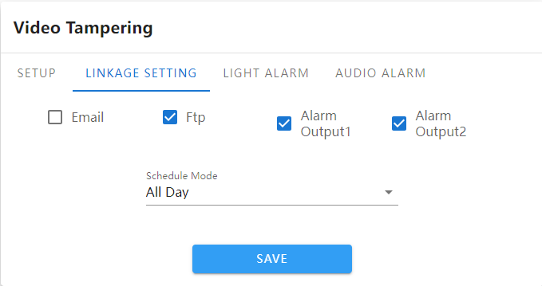
Linkage settings:
      - Upload email: select to enable or disable the alarm linkage function.
      - FTP: enable the function to capture and push a picture to the FTP server at the beginning and end of the alarm.
      - Alarm output 1: enable or disable alarm linkage alarm output 1.
      - Alarm output 2: enable or disable alarm linkage alarm output 2.
      - Deployment mode: divided into full day deployment, night deployment, and custom deployment, set as needed.
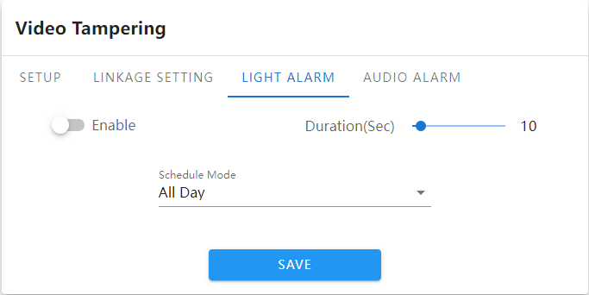
      - Enable: the alarm indicator light can be set to prompt after triggering.
      - Alarm duration: the parameter can be selected from 1 to 100, and the default display parameter is 10.
      - Deployment mode: divided into full day deployment, night deployment, and custom deployment, set as needed.
      - 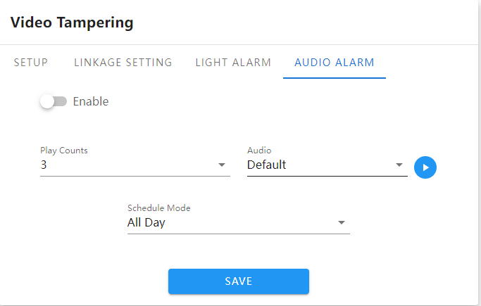
      - Enable: can trigger occlusion alarms to generate alarm related prompt sounds.
      - Playback count: selectable from 1 to 10 and looping, default display is 3 times.
      - Audio: when an alarm is triggered, the alarm prompt sound will sound. Click the play button to try listening to the alarm voice.
      - Deployment mode: divided into full day deployment, night deployment, and custom deployment, set as needed.
After setting the parameters, click the [Save] button and the settings will take effect.

4.5.12 Regional Intrusion

The area intrusion setting interface of IP Camera is shown in the following figure:
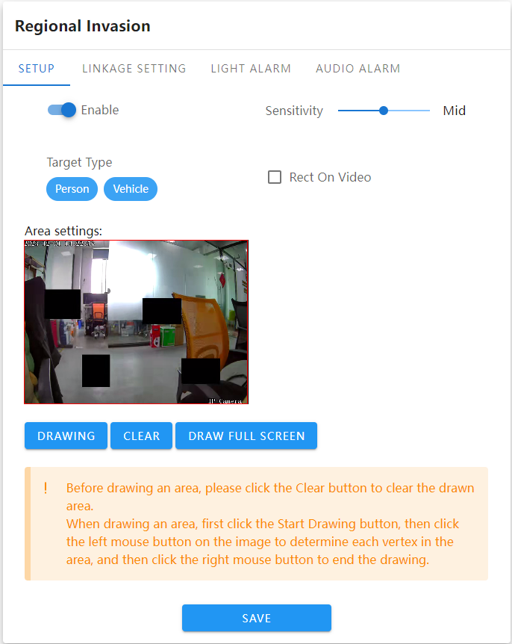

      - Enable: set whether to enable the area intrusion detection function.
      - Sensitivity: the higher the sensitivity, the easier it is to trigger an alarm.
      - Target type: optional human or vehicle shapes for detection.
      - Video stream overlay detection box: enable or disable the detection box overlay on video stream function.
      - Set Region: set the detection region for the desired rule configuration, supporting polygon detection regions.
      - Set detection area: use the mouse to click on the area that needs to be marked on the channel screen, hold down the left mouse button to click on the screen, and then click the left mouse button again to the appropriate position until the drawing is completed. The length and width can be customized by the operator. If the setting is not ideal, you can click to erase and reset the area. (Supports six point line drawing)

      - Draw full screen detection: click the button to draw the detection area in full screen with one click 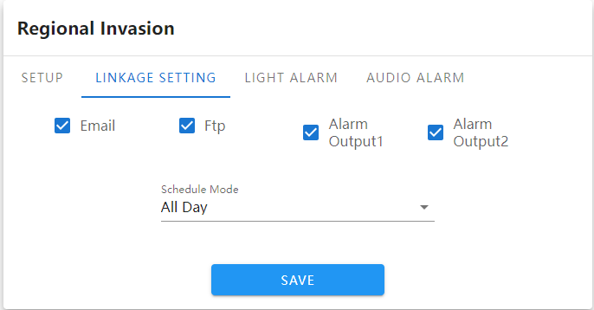
Linkage settings:
      - Upload email: select to enable or disable the alarm linkage function.
      - FTP: enable the function to capture and push a picture to the FTP server at the beginning and end of the alarm.
      - Alarm output 1: enable or disable alarm linkage alarm output 1.
      - Alarm output 2: enable or disable alarm linkage alarm output 2.
      - Deployment mode: divided into full day deployment, night deployment, and custom deployment, set as needed.
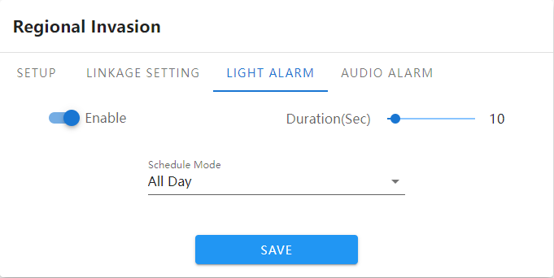
      - Enable: the alarm indicator light can be set to prompt after triggering.
      - Alarm duration: the parameter can be selected from 1 to 100, and the default display parameter is 10.
      - Deployment mode: divided into full day deployment, night deployment, and custom deployment, set as needed.
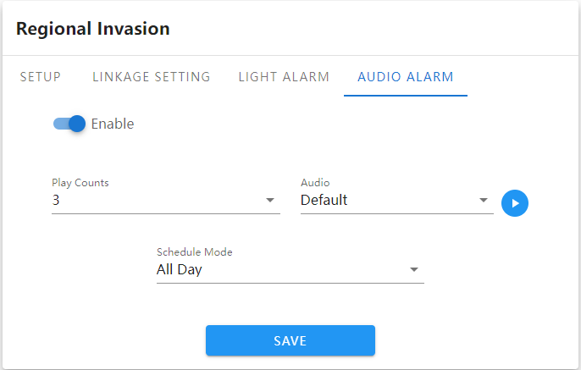
      - Enable: it is possible to activate the triggering area intrusion to generate alarm related prompt sounds.
      - Playback count: selectable from 1 to 10 and looping, default display is 3 times.
      - Audio: when an alarm is triggered, the alarm prompt sound will sound. Click the play button to try listening to the alarm voice.
      - Deployment mode: divided into full day deployment, night deployment, and custom deployment, set as needed.
After setting the parameters, click the [Save] button and the settings will take effect.

4.5.13 Line Crossing Detection

The line detection setting interface of IP Camera is shown in the following figure:
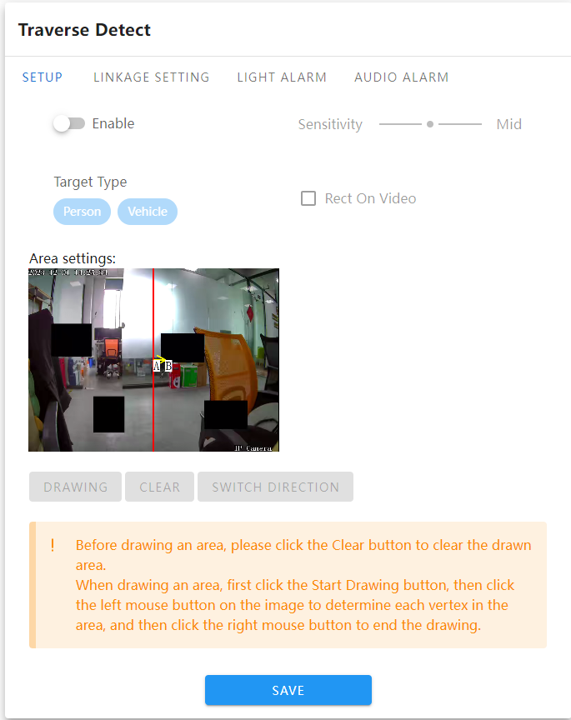
      - Enable: set whether to enable the line detection function.
      - Sensitivity: the higher the sensitivity, the easier it is to trigger an alarm.
      - Target type: optional human or vehicle shapes for detection.
      - Video stream overlay detection box: enable or disable the detection box overlay on video stream function.
      - Set Area: set the detection area where you want to configure rules
      - Set detection area: use the mouse to click on the area that needs to be marked on the channel screen, hold down the left mouse button to click on the screen, and then click the left mouse button again at the appropriate position to end the drawing. The length can be customized by the operator. If the setting is not ideal, you can click to erase and reset the area.
      - Switch direction: click the switch direction button to change the detection position.

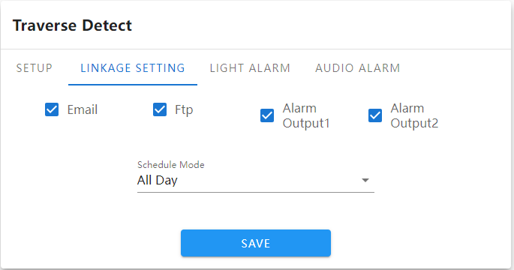

      - Linkage Setting：
      - Upload email: Choose to turn on or off the alarm linkage function
      - FTP: Enable the function and grab a picture when the alarm starts and ends and push it to the FTP server.
      - Alarm output 1: Enable or disable alarm linkage alarm output 1.
      - Alarm output 2: Enable or disable alarm linkage alarm output 2.
      - Arming mode: divided into all-day arming, night arming and customized arming, set as needed.

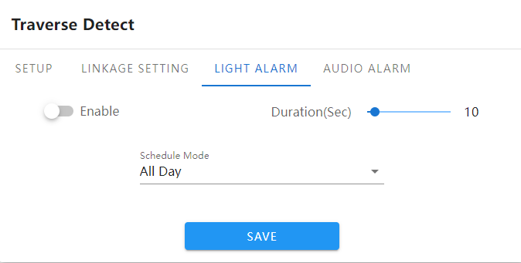
      - Enable：it can set the alarm indicator light prompt after triggering.
      - Alarm duration: The parameter can be selected from 1-100, and parameter 10 is displayed by default
      - Arming mode: divided into all-day arming, night arming and customized arming, set as needed.
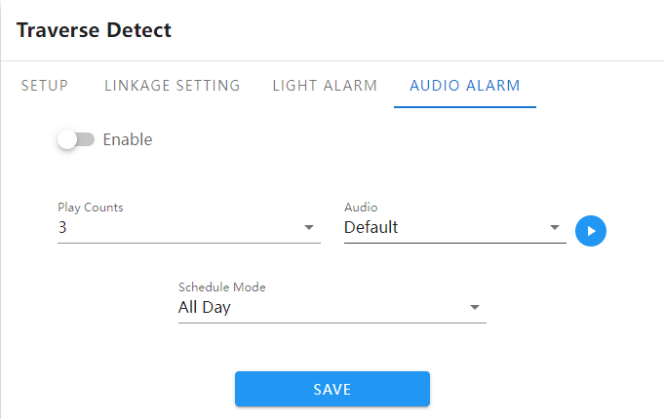
      - Enable: It can enable triggering Line-crossing detection to generate alarm-related prompts.
      - Number of playbacks: options range from 1-10 and loop, displayed 3 times by default
      - Audio: The alarm is triggered and the alarm prompt sounds. Click the play button to listen to the alarm voice.
      - Arming mode: divided into all-day arming, night arming and customized arming, set as needed.
      - After setting the parameters, click the [Save] button and the settings will take effect.

4.5.14 Loitering
IP Camera Loitering setting interface as follows：

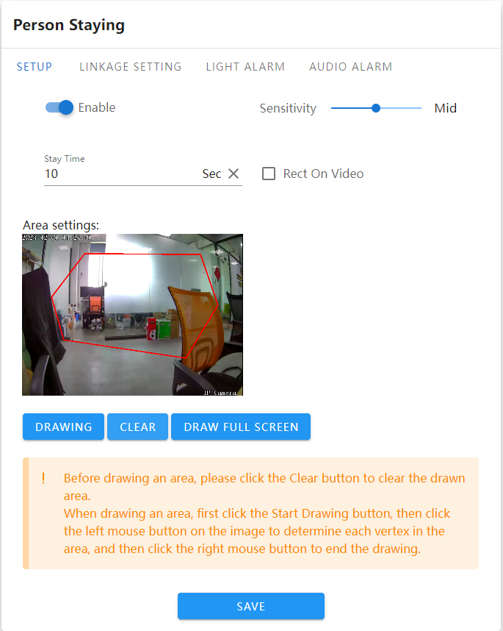
      - Enable: Set whether to enable the area people loitering detection function.
      - Sensitivity: The higher the sensitivity, the easier it is to trigger the alarm
      - Loitering time: fill in the range [10, 3600], the default display is 10 seconds.
      - Video stream overlay detection frame: Enable or disable the detection frame overlay function on the video stream.
      - Set area: Set the detection area where the rules are to be configured. Polygon detection area is supported.
      - Set the detection area: Use the mouse to click on the area that needs to be drawn on the channel screen, hold down the left mouse button and click on the screen, go to the appropriate position and click the left mouse button again until the drawing is completed. The length and width are customized by the operator, and some settings are not correct. you can click Erase to reset the area. (Supports six-point line drawing)
      - Draw full screen detection :Click the button to draw the detection area in full screen with one click.
.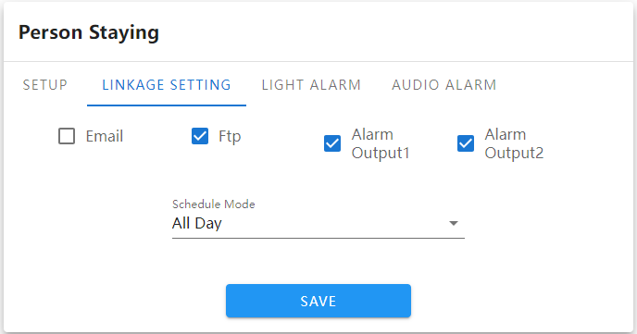
Linkage Setting：
      - Upload email: Choose to turn on or off the alarm linkage function
      - FTP: Enable the function and grab a picture when the alarm starts and ends and push it to the FTP server.
      - Alarm output 1: Enable or disable alarm linkage alarm output 1.
      - Alarm output 2: Enable or disable alarm linkage alarm output 2.
      - Arming mode: divided into all-day arming, night arming and customized arming, set as needed.
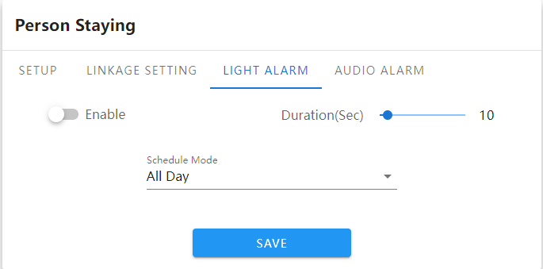
      - Enable：it can set the alarm indicator light prompt after triggering.
      - Alarm duration: The parameter can be selected from 1-100, and parameter 10 is displayed by default
      - Arming mode: divided into all-day arming, night arming and customized arming, set as needed.
.
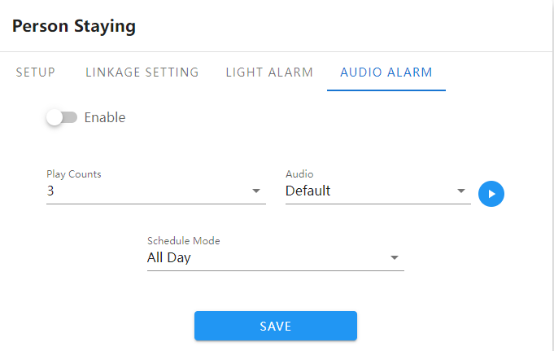
      - Enable: It can enable triggering Loitering detection to generate alarm-related prompts.
      - Number of playbacks: options range from 1-10 and loop, displayed 3 times by default
      - Audio: The alarm is triggered and the alarm prompt sounds. Click the play button to listen to the alarm voice.
      - Arming mode: divided into all-day arming, night arming and customized arming, set as needed.
After setting the parameters, click the [Save] button and the settings will take effect.

4.5.15 Absence Detection

IP Camera Setting interface for Staff Absence as follows:

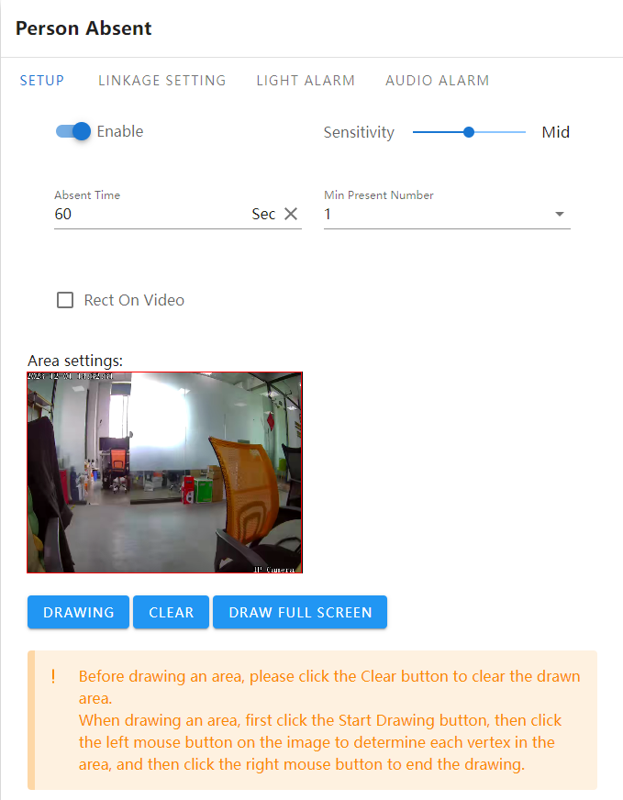
      - Enable: Set whether to enable the area people Staff absence detection function.
      - Sensitivity: The higher the sensitivity, the easier it is to trigger the alarm
      - Loitering time: fill in the range [10, 3600], the default display is 60 seconds.
      - Minimum number of people on duty: Three parameters can be saved:1/2/3.
      - Video stream overlay detection frame: Enable or disable the detection frame overlay function on the video stream.
      - Set area: Set the detection area where the rules are to be configured. Polygon detection area is supported.
      - Set the detection area: Use the mouse to click on the area that needs to be drawn on the channel screen, hold down the left mouse button and click on the screen, go to the appropriate position and click the left mouse button again until the drawing is completed. The length and width are customized by the operator, and some settings are not correct . you can click Erase to reset the area. (Supports six-point line drawing)
      - Draw full screen detection: Click the button to draw the detection area in full screen with one click.

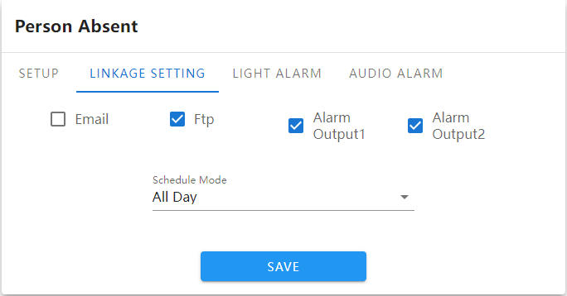
Linkage Setting：
      - Upload email: Choose to turn on or off the alarm linkage function
      - FTP: Enable the function and grab a picture when the alarm starts and ends and push it to the FTP server.
      - Alarm output 1: Enable or disable alarm linkage alarm output 1.
      - Alarm output 2: Enable or disable alarm linkage alarm output 2.
      - Arming mode: divided into all-day arming, night arming and customized arming, set as needed.
。
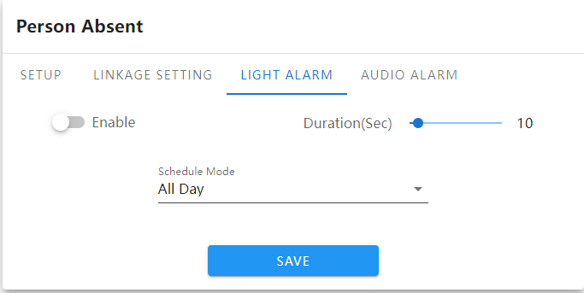
      - Enable：it can set the alarm indicator light prompt after triggering.
      - Alarm duration: The parameter can be selected from 1-100, and parameter 10 is displayed by default
      - Arming mode: divided into all-day arming, night arming and customized arming, set as needed.
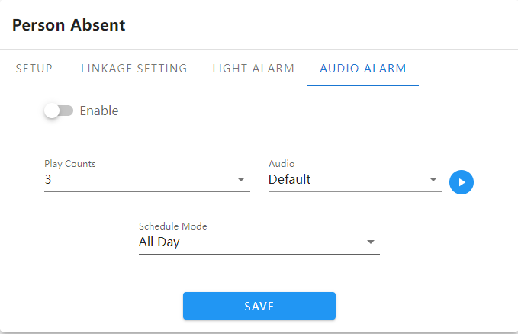
      - Enable: It can enable triggering Staff absence detection to generate alarm-related prompts.
      - Number of playbacks: options range from 1-10 and loop, displayed 3 times by default
      - Audio: The alarm is triggered and the alarm prompt sounds. Click the play button to listen to the alarm voice.
      - Arming mode: divided into all-day arming, night arming and customized arming, set as needed.
After setting the parameters, click the [Save] button and the settings will take effect.

4.5.16 Vehicle Illegal Parking

IP Camera Vehicle illegal Parking setting interface as follows:
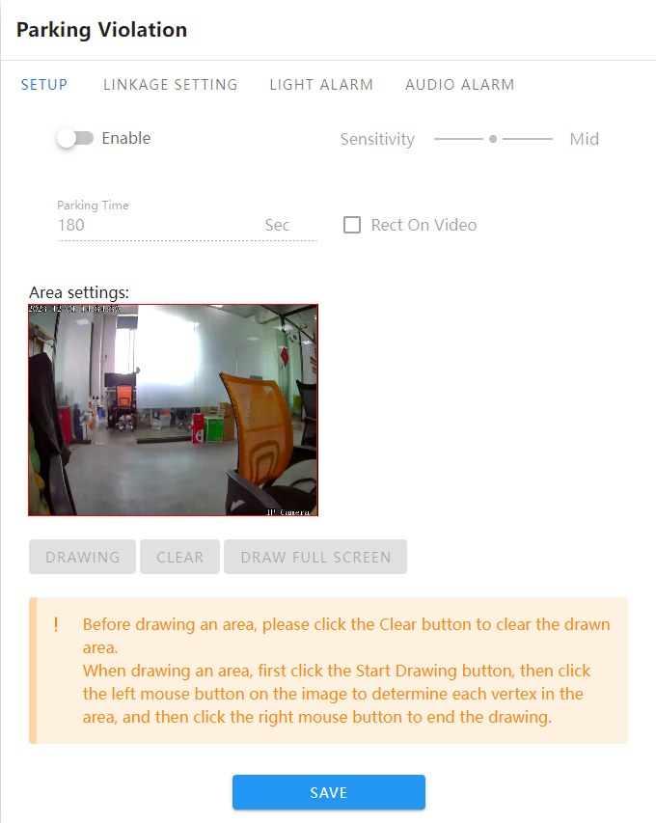
      - Enable: Set whether to enable the area Vehicle illegal Parking detection function.
      - Sensitivity: The higher the sensitivity, the easier it is to trigger the alarm
      - Stay time: fill in the range [10, 3600], the default display is 180 seconds.
      - Video stream overlay detection frame: Enable or disable the detection frame overlay function on the video stream.
      - Set area: Set the detection area where the rules are to be configured. Polygon detection area is supported.
      - Set the detection area: Use the mouse to click on the area that needs to be drawn on the channel screen, hold down the left mouse button and click on the screen, go to the appropriate position and click the left mouse button again until the drawing is completed. The length and width are customized by the operator, and some settings are not correct. you can click Erase to reset the area. (Supports six-point line drawing)
      - Draw full screen detection: Click the button to draw the detection area in full screen with one click.

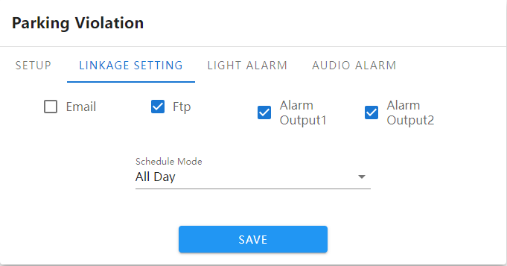
Linkage Setting：
      - Upload email: Choose to turn on or off the alarm linkage function
      - FTP: Enable the function and grab a picture when the alarm starts and ends and push it to the FTP server.
      - Alarm output 1: Enable or disable alarm linkage alarm output 1.
      - Alarm output 2: Enable or disable alarm linkage alarm output 2.
      - Arming mode: divided into all-day arming, night arming and customized arming, set as needed.
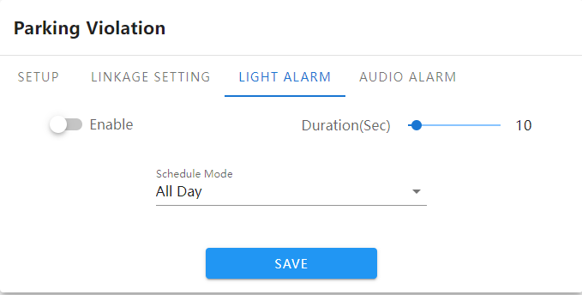
      - Enable：it can set the alarm indicator light prompt after triggering.
      - Alarm duration: The parameter can be selected from 1-100, and parameter 10 is displayed by default
      - Arming mode: divided into all-day arming, night arming and customized arming, set as needed.
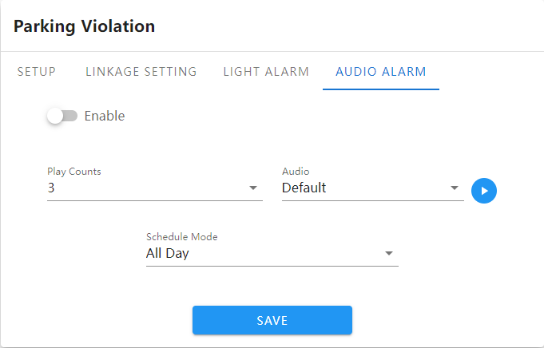

      - Enable: It can enable triggering vehicle illegal parking to generate alarm-related prompts.
      - Number of playbacks: options range from 1-10 and loop, displayed 3 times by default
      - Audio: The alarm is triggered and the alarm prompt sounds. Click the play button to listen to the alarm voice.
      - Arming mode: divided into all-day arming, night arming and customized arming, set as needed.

After setting the parameters, click the [Save] button and the settings will take effect.

4.5.17 Vehicle Retrograde

IP Camera Vehicle Retrograde interface as follows:
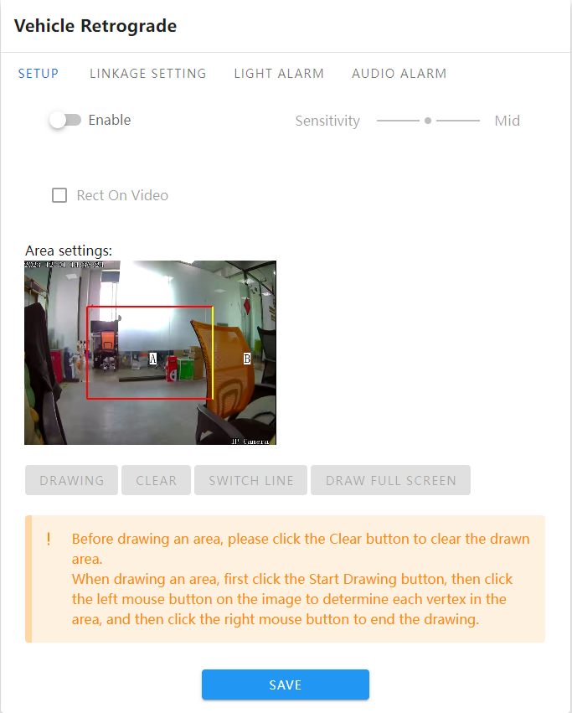
      - Enable: Set whether to enable the area Vehicle Retrograde detection function.
      - Sensitivity: The higher the sensitivity, the easier it is to trigger the alarm
      - Video stream overlay detection frame: Enable or disable the detection frame overlay function on the video stream.
      - Set area: Set the detection area where the rules are to be configured.
      - Set the detection area: Use the mouse to click on the area that needs to be drawn on the channel screen, hold down the left mouse button and click on the screen, go to the appropriate position and click the left mouse button again until the drawing is completed. The length and width are customized by the operator, and some settings are not correct. you can click Erase to reset the area. (Supports four-point line drawing)
      - Switch detection line: Click the switch detection line button to change the detection position
      - Draw full screen detection: Click the button to draw the detection area in full screen with one click.

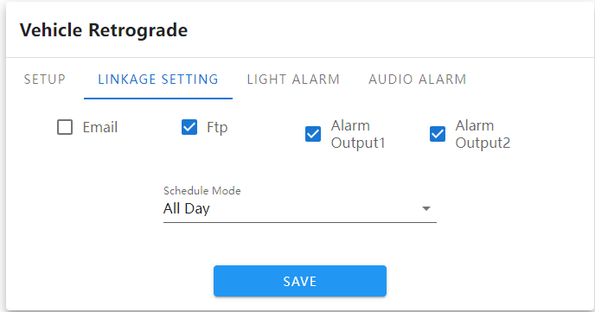
Linkage Setting：
      - Upload email: Choose to turn on or off the alarm linkage function
      - FTP: Enable the function and grab a picture when the alarm starts and ends and push it to the FTP server.
      - Alarm output 1: Enable or disable alarm linkage alarm output 1.
      - Alarm output 2: Enable or disable alarm linkage alarm output 2.
      - Arming mode: divided into all-day arming, night arming and customized arming, set as needed.
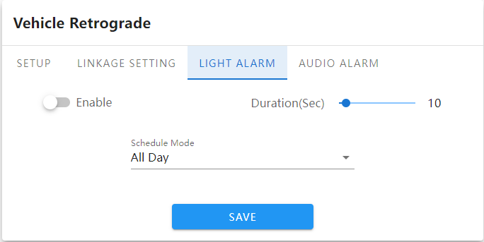
      - Enable：it can set the alarm indicator light prompt after triggering.
      - Alarm duration: The parameter can be selected from 1-100, and parameter 10 is displayed by default
      - Arming mode: divided into all-day arming, night arming and customized arming, set as needed.
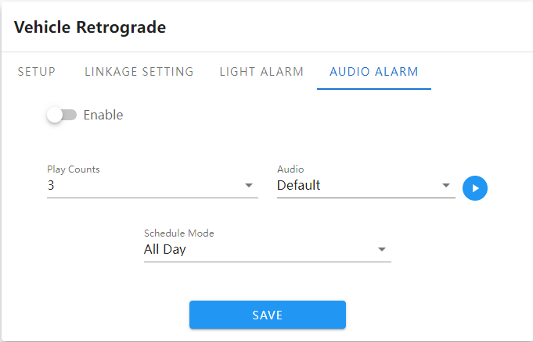
      - Enable: It can enable triggering vehicle illegal parking to generate alarm-related prompts.
      - Number of playbacks: options range from 1-10 and loop, displayed 3 times by default
      - Audio: The alarm is triggered and the alarm prompt sounds. Click the play button to listen to the alarm voice.
      - Arming mode: divided into all-day arming, night arming and customized arming, set as needed.
After setting the parameters, click the [Save] button and the settings will take effect.

4.5.18 Recording Configuration

IP Camera’s recording configuration interface as follows:

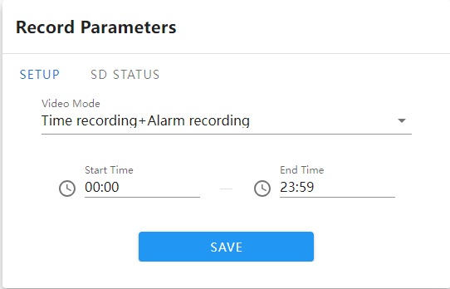
      - Recording mode：three type of recording modes: timing recording,alarm recording and timing recording+ alarm recording, default timing+alarm recording
      - Start time-end time: set recording time period
      - SD card status：Display current SD card storage status.
      - Format：If user does not need SD card to record and save storage capacity, user can format SD card.
After finish setting parameters, click”save”, then it would be valid

4.5.19 Network Setting

IP Camera’s network setting interface as follows:
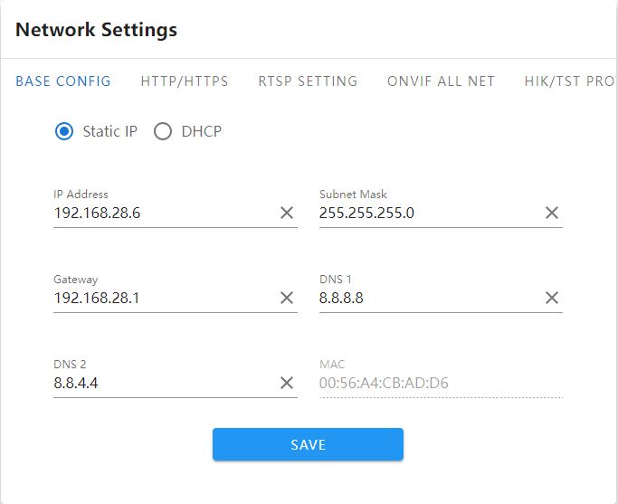

      - IPV4：IP protocol version is 4.
      - Static IP IP：The IP of the device is fixed and the default is 192.168.1.188.
      - DHCP：If the router turns on the DHCP function, the camera will automatically obtain an IP address from the router after selecting this setting.
      - IP address: Enter the corresponding number to change the IP address.
      - Subnet mask: Enter the subnet mask of the corresponding IP.
      - Gateway address: Enter the corresponding gateway address.

      - Preferred DNS：DNS server IP address.
      - Alternate DNS：DNS server alternative IP address
After setting the parameters, click the [Save] button and the settings will take effect.

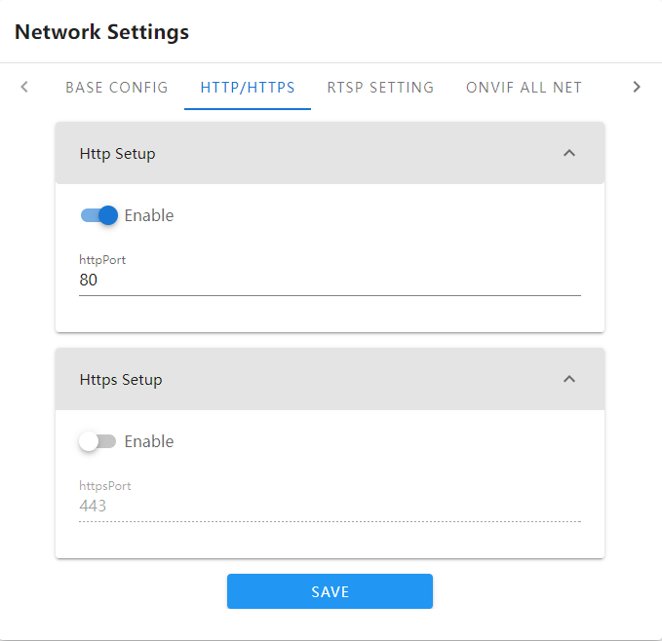
HTTP/HTTPS Setting：
      - Default Http Port：80。
      - Deafult Https Port：443

After setting the parameters, click the [Save] button and the settings will take effect.
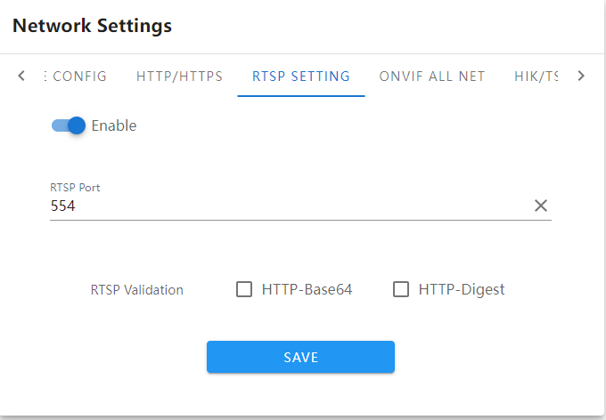
RTSP Setting：
      - RTSP Port：Deafult 554。
      - RTSP verification：Whether to enable HTTP-Base64 and HTTP-Digest verification. HTTP-Digest is enabled by default.
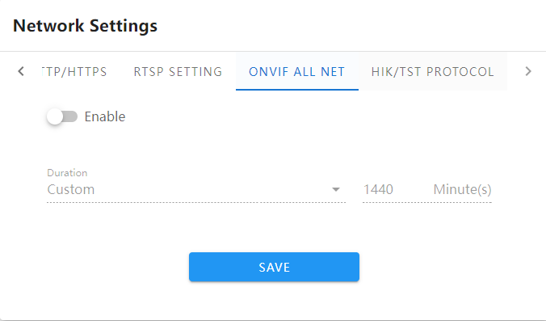

ONVIF All network settings ：
      - Enable: Select enable or disable enable.
      - Duration: The duration can be set to 1/2/3/6/12 hours and user-defined.
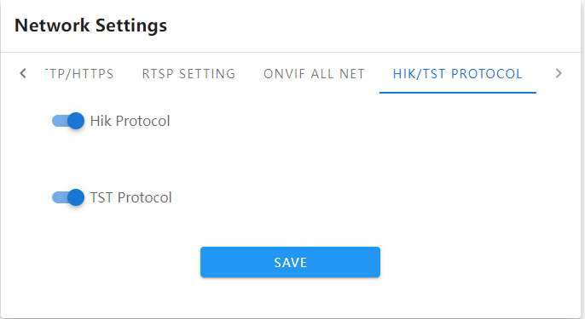
Hik/TST Settings：
      - HiK protocol: Enable or disable HiK protocol.
      - TST protocol: Enable or close the TST protocol.
After setting the parameters, click the [Save] button and the settings will take effect.

4.5.20 RTMP Setting

IP Camera The RTMP setting interface is shown below:
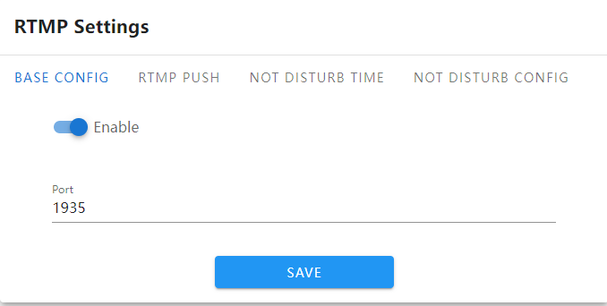
      - Basic settings: enable or disable RTMP function.
      - Port：The port number is 1935.
      - RTMP push: Fill in the RTMP push link.
      - Do-not-disturb time: Set the do-not-disturb time period. Eight time periods can be set every day.
      - Do not disturb setting: Set the client that supports do not disturb time and can work normally.
After setting the parameters, click the [Save] button and the settings will take effect.

4.5.21 Http(s)Push

IP Camera The Http(s) push interface is shown below:

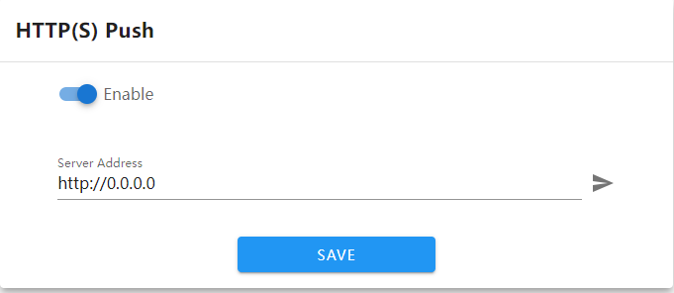
      - Enable: Enable or disable this function.
      - Server address: Fill in the Http/https address to connect to the server.。
After setting the parameters, click the [Save] button and the settings will take effect.

4.5.22 Mobile Monitoring

IP Camera the mobile phone monitoring interface of IP Camera is as shown below：
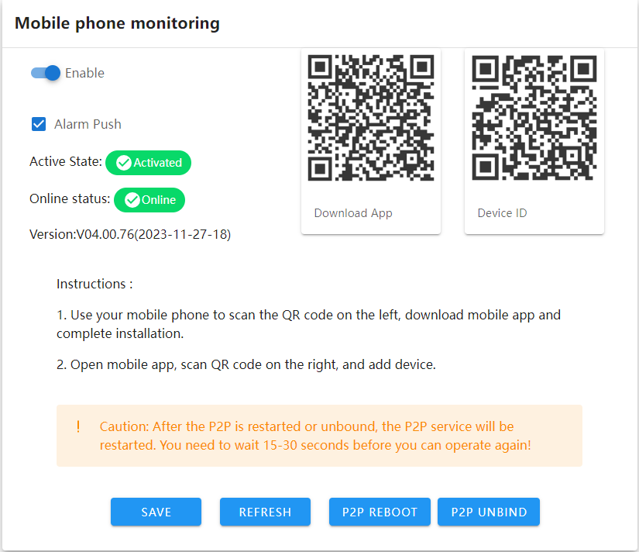
      - Enable: Enable or disable the mobile phone monitoring module.
      - Alarm push: Check to enable the alarm to be pushed to the mobile APP.
      - Activation status: If it is activated, you can scan the code to add it to the mobile app. If it is not activated, the word "Inactivated" will be displayed.
      - Online status: When the device is connected to the Internet, it displays "Online"; when the device is not connected to the Internet, it displays "Offline".
      - Download the APP: Scan the QR code on WeChat to jump to the APP download address.
      - Device ID: Use the app to scan the QR code and add it to the APP for viewing.
After setting the parameters, click”save”button, then the setting will take effect.

4.5.23 Platform Management

The platform management setting interface of IP Camera is shown in the figure below:：

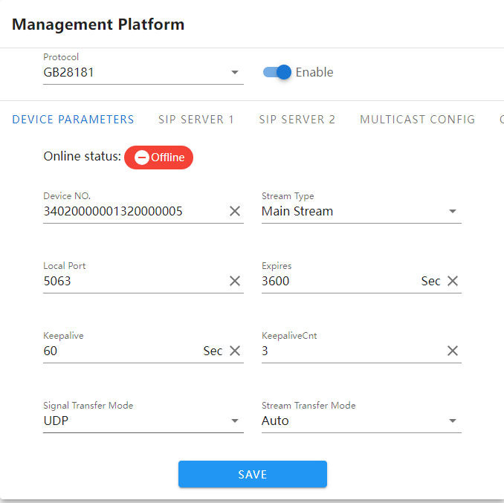
Enable the national standard function, fill in the corresponding parameters one by one, save them, and connect to the national standard platform for outflow. Please refer to the national standard parameter document for detailed filling.

4.5.24 Multicast Configuration

The multicast setting interface of IP Camera is as shown below:：
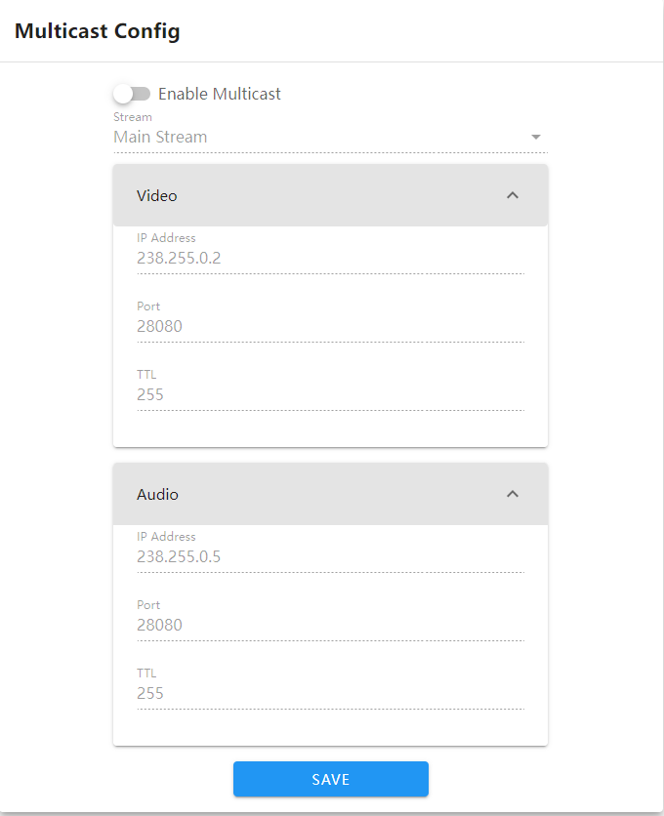

Multicast is disabled by default. After enabling it, you can set the IP address, port, and TTL of the multicast main stream, sub-stream, and video and audio. After setting the parameters, click the [Save] button and the settings will take effect.

4.5.25 Email Setting

The EMALL setting interface of IP Camera is shown in the figure below：
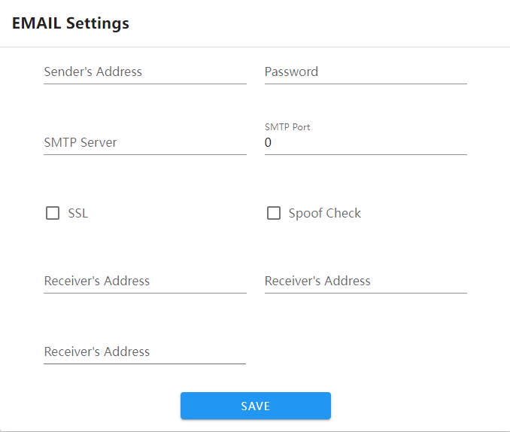
Fill in the complete EMALL sending email and receiving email information. If the alarm is checked and EMALL is linked, the alarm information will be pushed to the receiving email when the alarm is triggered.

4.5.26 FTP Setting

The FTP setting interface of IP Camera is shown in the figure below：

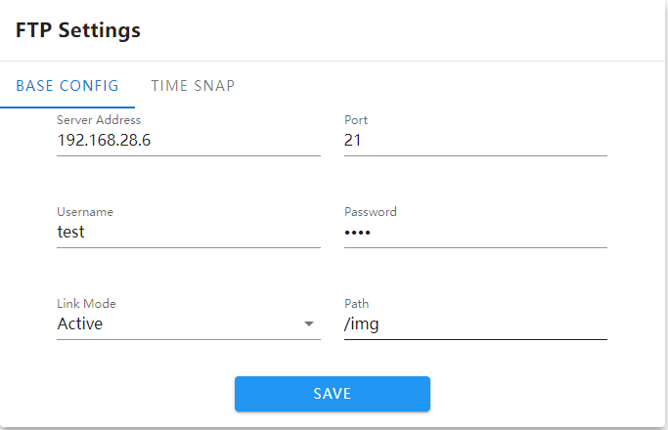
      - Server address: Fill in the FTP server address.
      - Port: Fill in the same value as the FTP server.
      - Username: Fill in the FTP server username.
      - Password: Fill in the FTP server password.
      - Linkage mode: Active by default, no modification is required.
      - Path: Fill in the FTP image saving path
      - Snapshot interval: Optional time setting, you can also customize the snapshot time.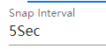
      - Stream type: Select the image resolution for scheduled push images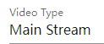
      - Arming mode: divided into three types: all-day, night and customized arming time。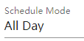
After setting the parameters, click the [Save] button and the settings will take effect.

4.5.27 Alarm Input

The alarm output setting interface of IP Camera is as shown below：

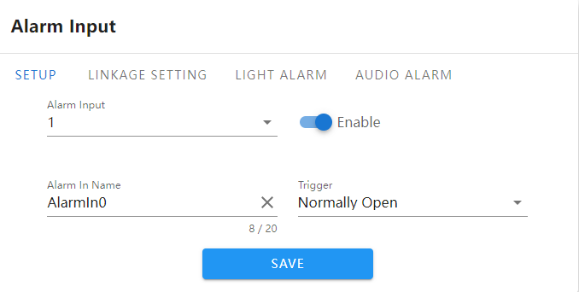
      - Alarm input: Default 1 cannot be modified.
      - Enable: Enable or disable the current function.
      - Alarm input name: can be modified.
      - Trigger level: divided into normally open and normally closed, the default is normally open.
      - Linkage setting: Same as the alarm module, check the parameters and trigger the alarm to link various options. (Note: Linked FTP only pushes the first picture)
      - Light alarm: Same as the alarm module.
      - Audio alarm: Same as the alarm module.
After setting the parameters, click the [Save] button and the settings will take effect.

4.5.28 Alarm Output

The user management setting interface of IP Camera is shown in the figure below：
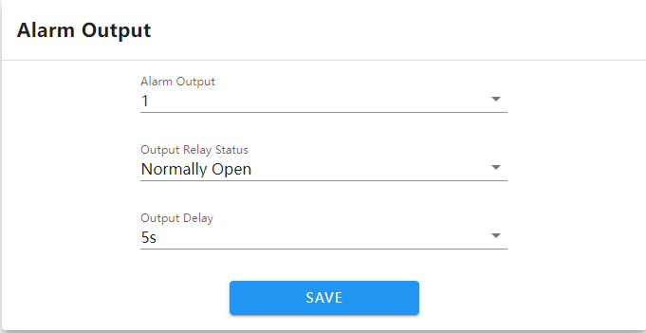
      - Alarm output: optional 1 or 2 settings.
      - Output relay status: Normally closed by default, normally open can be set.
      - Output alarm delay: choose different time settings according to needs
After setting the parameters, click the [Save] button and the settings will take effect.

4.5.29 User Management

The user management setting interface of IP Camera is as shown below:
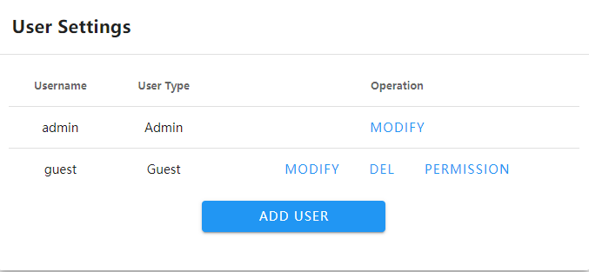
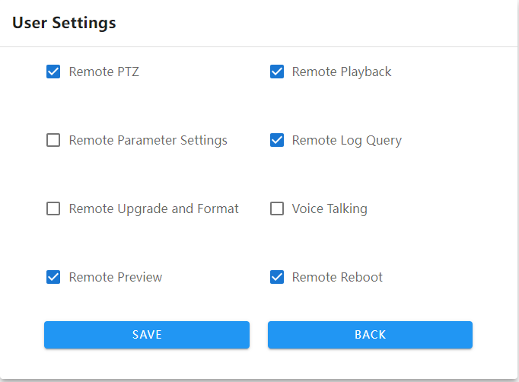
By default, the system has two users: admin (administrator) and guest (normal user). The passwords of these two users can be modified. The admin administrator user cannot be deleted, and the guest user can be deleted. You can add new users as needed and configure the new user's permissions (see the figure above for set permissions). New users can be deleted.

4.5.30 System Upgrade

The system upgrade setting interface of IP Camera is as shown below:
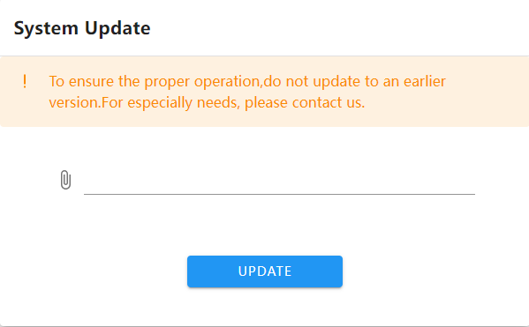
Click the link icon, select the upgrade file, and upgrade the device to the latest version.

4.5.31 Equipment Maintenance

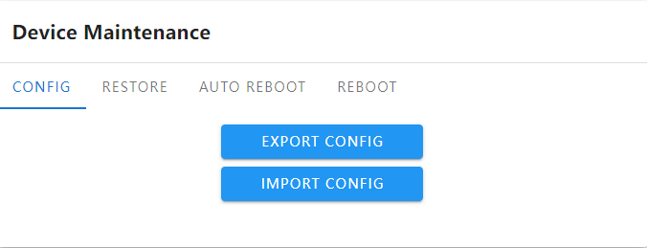

      - Export configuration: Export all configurations to PC or USB flash drive.

      - Import configuration: Import the specified configuration file into the system.

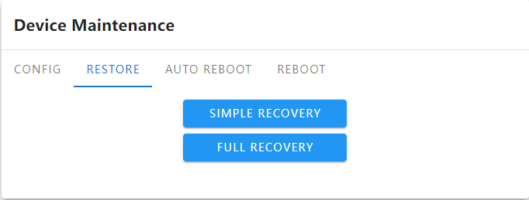

      - Simple recovery: Restore device parameters and retain Ethernet, password, OSD, and title related configurations.

      - Full recovery: restore device factory parameters
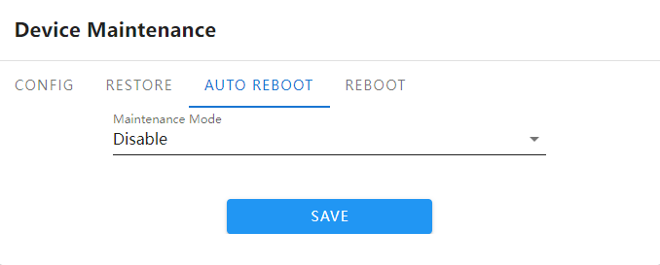
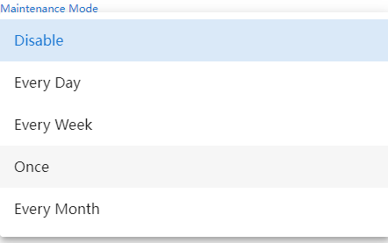

In the "Automatic Maintenance" page, there are 5 modes: disabled/daily/weekly/single/monthly. Select the maintenance mode, and the device will automatically restart according to the set specified mode and specified time point.。
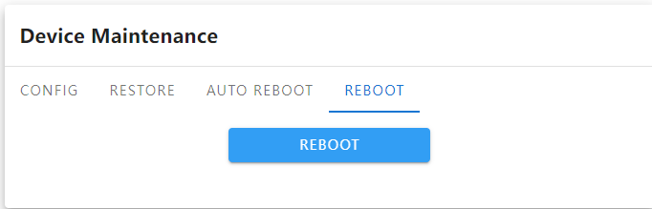

      - Restart: Restart the device immediately.

4.5.32 Developer Options
Note: This function is not enabled by default and is generally used by developers to debug programs remotely. For security reasons, users should not enable this option!

Exit The System
Click [Logout] to log out, as shown in the figure：

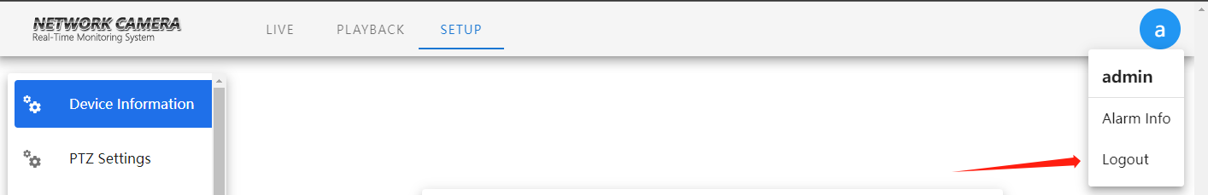

Common Troubleshooting
- How to know the IP address of the network camera？
- Method 1: The default IP address of our network camera is: 192.168.1.188. If you use this IP address directly to connect to the computer for the first time, you can directly log in to the Google Chrome management interface.
- Method 2: Our network camera turns on the DHCP (automatically obtain IP address) function and ONVIF full network function by default. If it is connected to the LAN or network hard disk recorder for the first time, the IP address will change. Use our network hard disk recorder, Network video surveillance software (IMS/ProductTool) or Upgrade IPC search upgrade tool can continue to search our network.
- Camera; if it is a third-party network hard disk video recorder that is connected for the first time, the IP address of the network camera will become the same network segment as the currently used IVR, and can be directly searched at this time.

- The following exceptions may occur when logging in with a browser
- "The URL you entered cannot be accessed"
Check whether the IP address format entered in the Google address bar is correct. Example of the correct format: http://192.168.1.188
Check whether the network camera is connected to the current network. Please use the Upgrade IPC search upgrade tool to search on this computer to ensure that it can be searched and that the IP address remains in the same network segment as the current computer (for specific searches, please refer to the "Upgrade IPC Search Upgrade Tool Instructions" ).
- Plug-in installation failed
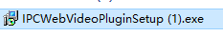
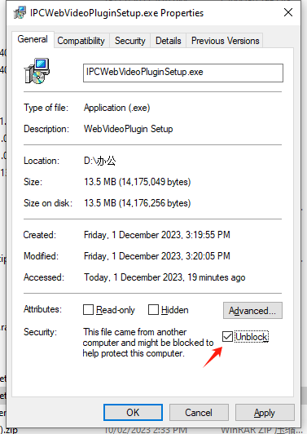
The security level of some computers and Google Chrome is too high. Double-clicking the plug-in does not pop up the installation interface, causing the installation to fail. Please enter the plug-in properties to unlock it, and double-click the plug-in again to install it. If the problem still cannot be solved, please contact technical support personnel

