Network Camera User Manual

V1.1 H5 Version

Contents
1.Login interface 2
2. Real-time Preview 3
2.1 Full screen preview 3
2.2 PTZ control 3
2.2 Stream type selection 4
2.3 Display intelligent detection 4
3. Playback 5
4. Parameter configuration 6
4.1 Device Information 6
4.2 Time Settings 7
4.3 Audio Settings 7
4.4 Voice output settings 8
4.5 Alarm lamp output 9
4.6 Display Settings 9
4.5 Encoding settings 10
4.6 Image Parameters 11
4.7 Motion Detection 12
4.8 Video Tampering 13
4.9 Privacy Zones 13
4.10 Human Detection 14
4.11 Video Plan 15
4.12 Network Settings 15
4.13 RTMP Settings 16
4.14 Management Platform 16
4.15 Multicast Config 17
4.16 EMAIl Settings 18
4.17 FTP Settings 19
4.18 Alarm Input 19
4.19 Alarm Output 20
4.20 User Settings 20
4.21 Storage Management 21
4.22 System Update 22
4.23 Device Maintenance 22
4.24 Developer 23
5.FILE Management 23
6.Logout 23

1. Login Interface

Enter the IP address of the camera in Google or Firefox (the default IP address is 192.168.1.188) to enter the login interface, as shown below:

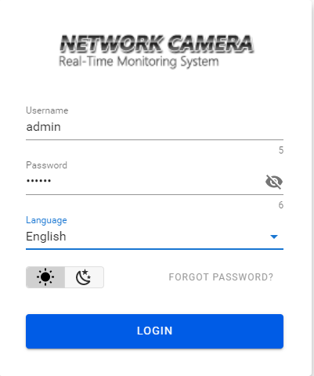

Username：admin（default）
Password：123456（default）
Language：Simplified Chinese, Traditional Chinese and English can be selected;
Forgot password: click this button to reset the password according to the wizard;
Select the sun icon to use the white page, and select the moon icon to use the black page;
Click [Login] to successfully log in to the camera.

Real-time Preview
After successful login, the interface is as follows:
Note: The device needs to be inserted with a TF card as a full function display interface,
otherwise, the device is a simple display interface. 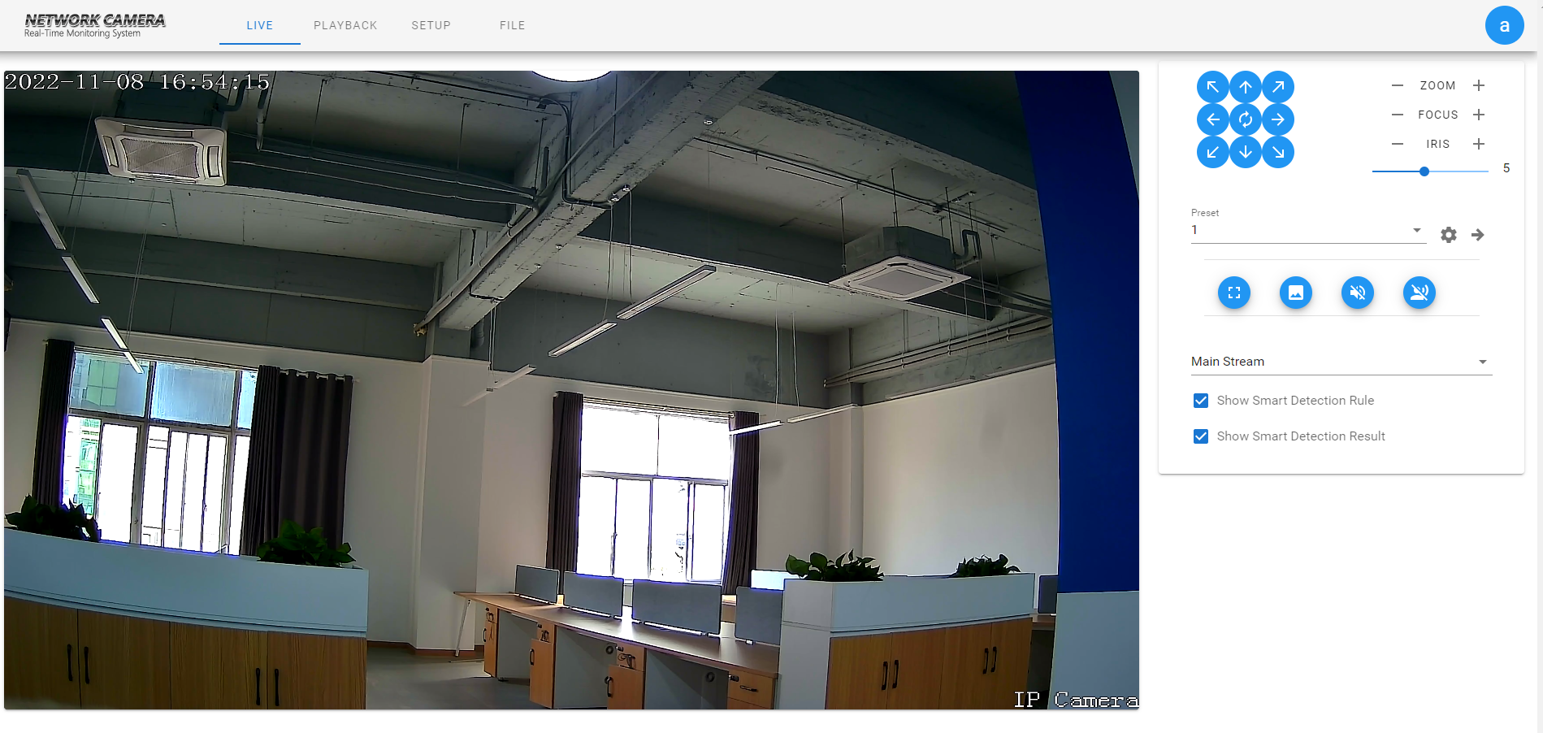

2.1 Full screen preview
Click the full screen icon to preview the full screen, and press ESC to exit the full screen

2.2 PTZ control
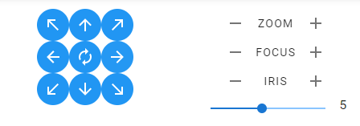
PTZ control：Eight direction keys can control the rotation of front-end equipment, and the middle is automatic rotation
Zoom：Adjustable zoom size
Focuse：Adjustable focus size
Iris：Adjustable iris size
Speed：The slider can control the speed of the PTZ

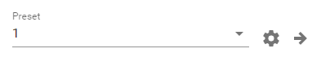
【Preset point setting】First, turn the camera to the desired position through the direction button controlled by the PTZ, then select a preset number in the "preset point" drop-down list, and finally click the setting button.
【Preset point call】Select a preset number to be called from the "preset point" drop-down list, and then click the call button.

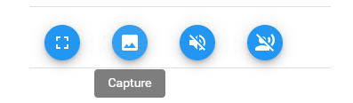
【Capture】Preview the snapshot, and click it to automatically pop up the snapshot saving path file
【Sound】Turn on/off sound preview
【Talk】Turn on/off voice intercom

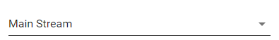

2.2 Stream type selection
Select the current main stream preview or sub stream preview

2.3 Display intelligent detection
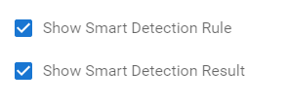
Display intelligent detection rules: select whether to display intelligent detection types
Display intelligent detection results: select whether to display the statistical results of intelligent detection

Playback

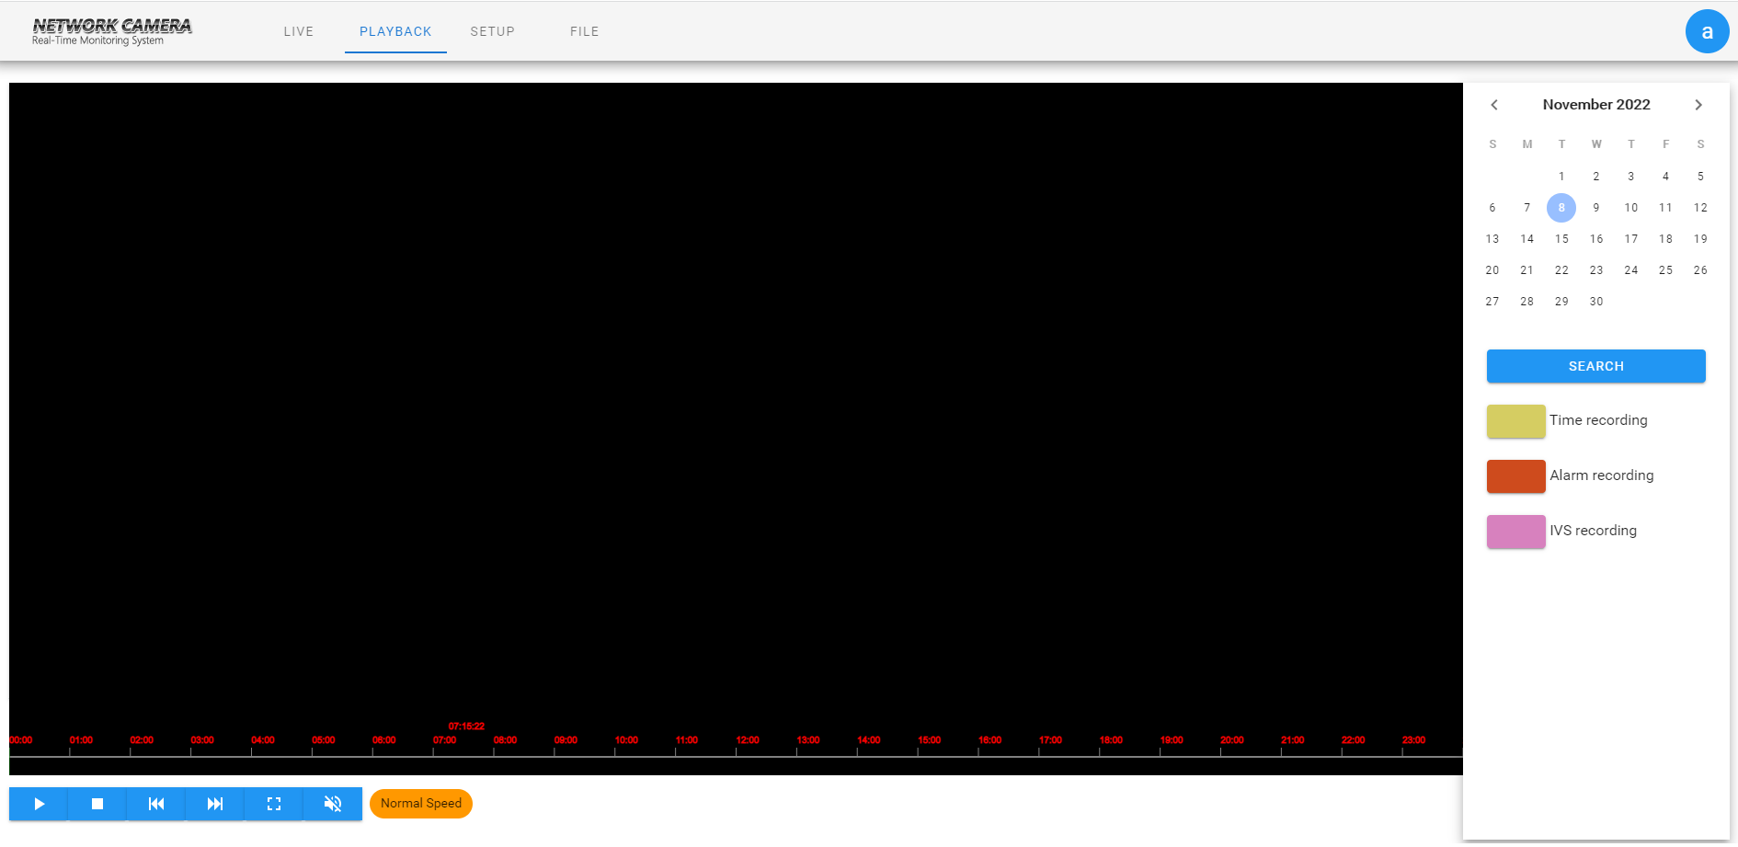
Click "Video Playback" to enter the playback interface, select the time to call the video, click seach button
 the video will be automatically retrieved;
play：Start current playback;
stop：Stop current playback;
Slow：Slow down playback speed (1/2, 1/4, 1/8, 1/16 times respectively);
Fast：Speed up playback (2, 4, 8, 16 times respectively);
Full screen：the playback screen will be displayed in full screen;
Sound：The sound in the video can be turned on/off.
Double click the position of the search bar to play, or click the "Play" button to start playback.
（Note: This function requires the device to support TF card storage.）

Parameter configuration
Note: The device needs to be inserted with a SD card as a full function display interface,
otherwise, the device is a simple display interface. 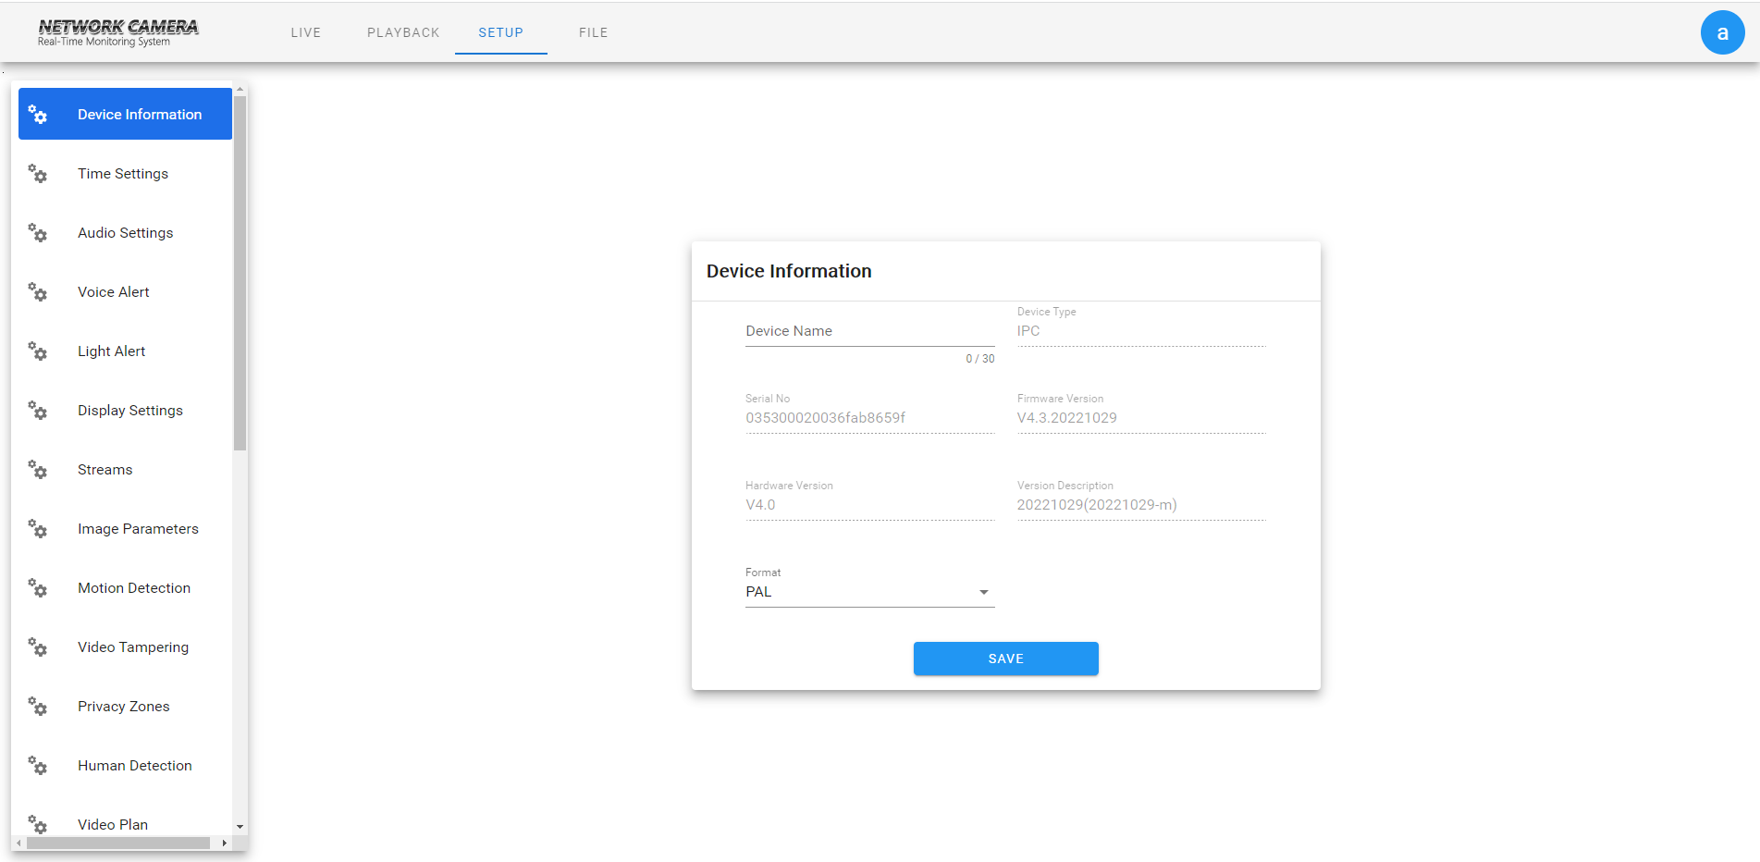

4.1 Device Information
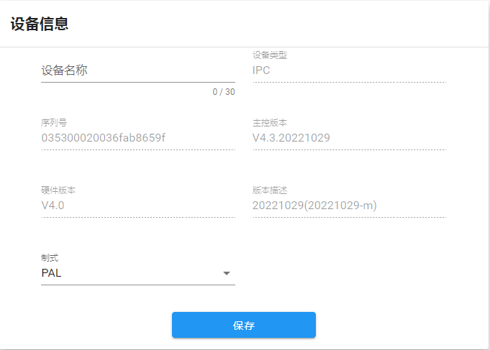
- Equipment Name: the name of the equipment can be set.
- Equipment Type: displays the equipment type.
- Serial Number: displays the product serial number.
- Master version: displays the software program version date.
- Hardware Version: Displays the version number of the hardware motherboard.
- System: PAL and NTSC image system can be switched.

4.2 Time Settings
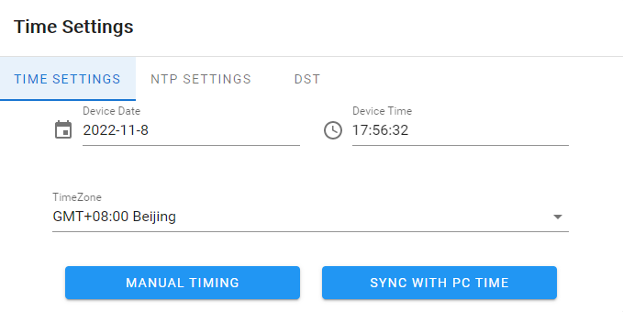
- Manual timing: set IPC time manually;
- synchronization with PC: synchronize the current PC time;

4.3 Audio Settings
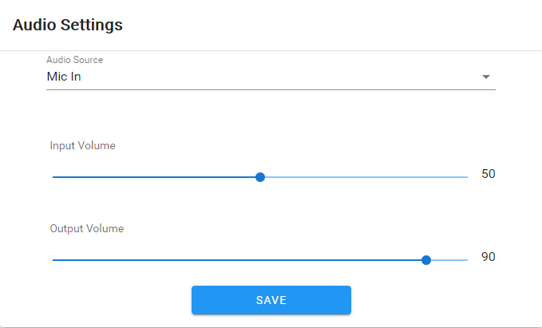

- Audio source: select microphone or line in;
- Input volume: set the volume of audio input;
- Output volume: set the volume of audio output;

4.4 Voice output settings
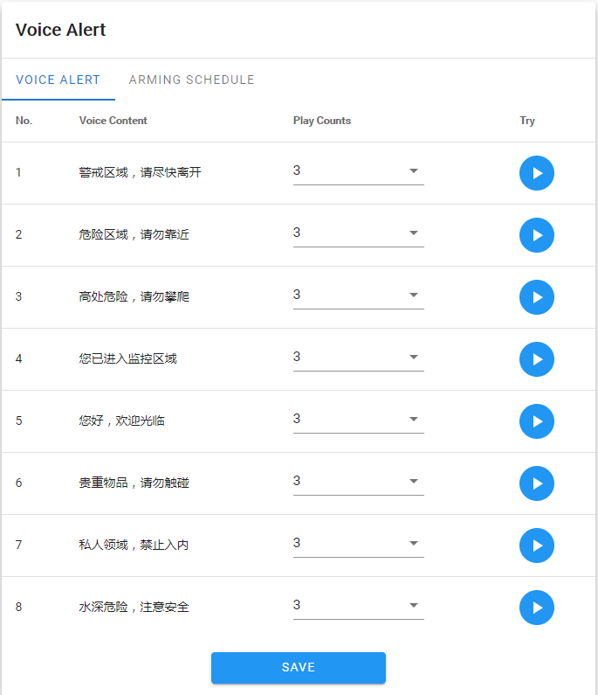

- Voice alarm output: you can set the playing times of 8 voice alarms and click to listen.
- Arming Schedule: the Arming Schedule of voice broadcast can be set.

4.5 Alarm lamp output

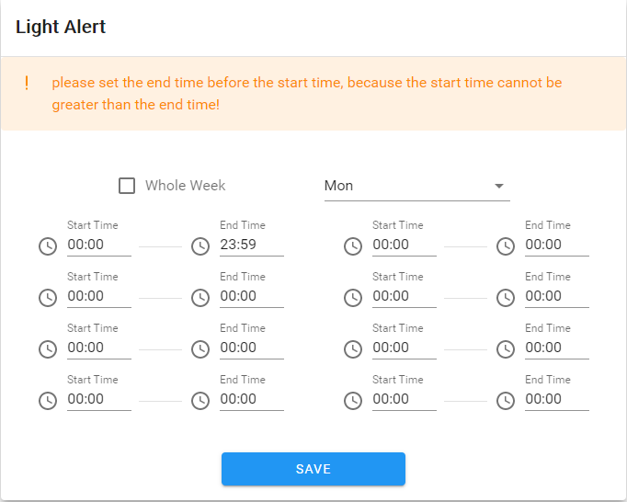
You can set the defence time of alarm lamp output, and click the [Save] button after setting to take effect.

4.6 Display Settings
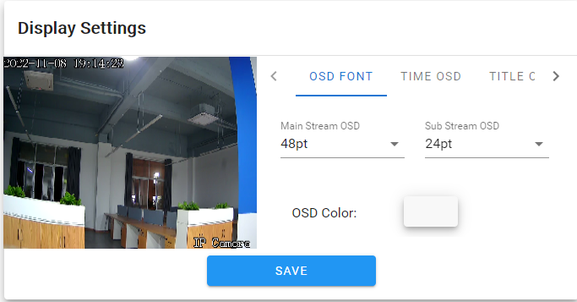
- OSD font: the OSD font size of the interface can be adjusted.
- Time OSD: Time OSD format and position can be adjusted.
- Title OSD: adjust the content, format and location of the title OSD.
- Multiline OSD: add multiline user-defined OSD character content and position, and you can select whether to display it.
- Hue: brightness/contrast/saturation/hue can be adjusted.

4.5 Encoding settings
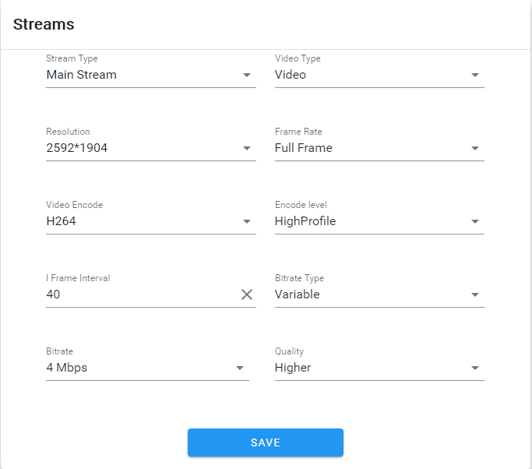
- Stream compression type: the main stream and sub stream coding types can be selected;
- Code stream type: including composite stream and video stream;
- Resolution: The front-end IPC supports several resolutions, and the corresponding ones will be displayed here;
- Video frame rate: different values can be selected from the drop-down list. The default value is Full Frame Rate;
- Code type: including H264/H265;
- Code Level: you can select a code level, including Baseline, MainProfile, and HighProfile;
- I frame interval: I frame interval can be set;
- Bit rate type: including fixed rate and variable rate;
- Bit rate: different bit rates can be set for different channels;
- Image quality: six types can be selected: best/sub good/good/average/poor/worst.

4.6 Image Parameters
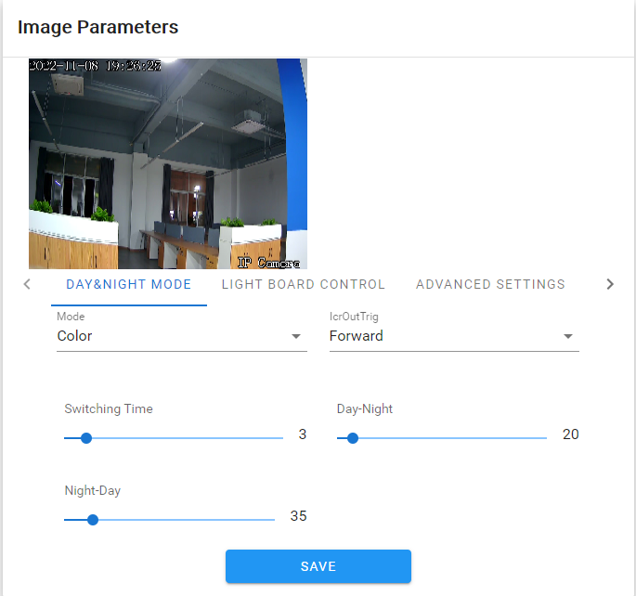

- Day night switch: divided into external trigger, automatic, color, black and white. The day and night switching mode of non infrared network model is automatic by default, and the day and night mode of infrared network model is external trigger by default. The user selects the day and night switching mode according to the network machine model and the actual use scenario;
Color mode: divided into three types: standard, gorgeous and natural; The color mode defaults to standard;
IRCUT trigger: it is divided into forward/reverse, which is related to the actual IRCUT hardware;
Switching time: the day night switching delay value (0-30) is 3 seconds by default;
Day night switching threshold: the default value is 20, and the threshold range is 0-255. The value can be adjusted according to customer needs;
Night day switching threshold: the default value is 35, and the threshold range is 0-255. The value can be adjusted according to customer needs;
- Fill light setting: light mode, switching mode and light brightness can be set;
- Advanced settings: you can set image mode, wide dynamic mode, 3D time domain, sharpness, defogging function, night frame reduction, and white balance;
- Exposure control: backlight mode, exposure allocation strategy, gain control, shutter and infrared light receiving can be set;
- GAMMA: GAMMA value and power frequency can be set.

4.7 Motion Detection
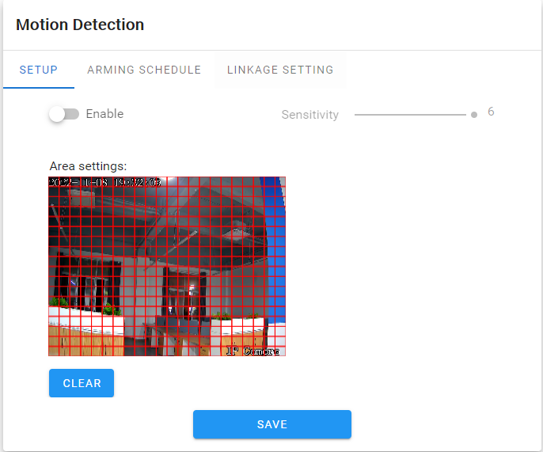

- Parameter setting: you can set whether to enable the detection function, set the detection sensitivity, and set the detection area;
- Deployment Time: you can set the deployment time from Monday to Sunday;
- Linkage setting: you can set the linkage to upload email, video, FTP, alarm light, alarm output, capture, and voice broadcast.

4.8 Video Tampering

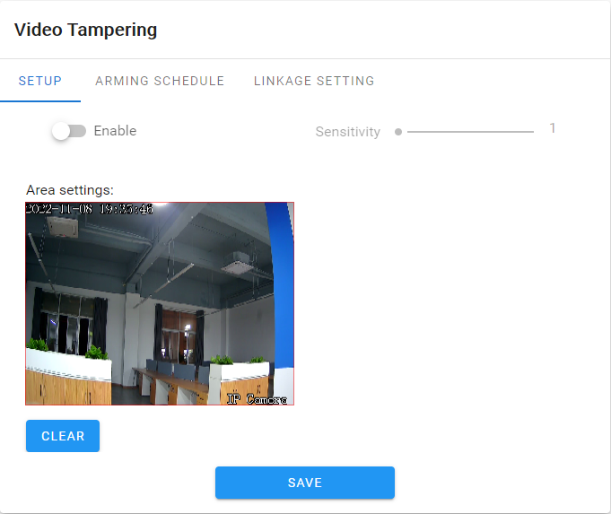
- Parameter configuration: you can set whether to enable the detection function, set the detection sensitivity, and set the detection area;
- Deployment Time: you can set the deployment time from Monday to Sunday;
- Linkage setting: you can set the linkage to upload email, video, FTP, alarm light, alarm output, capture, and voice broadcast;

4.9 Privacy Zones
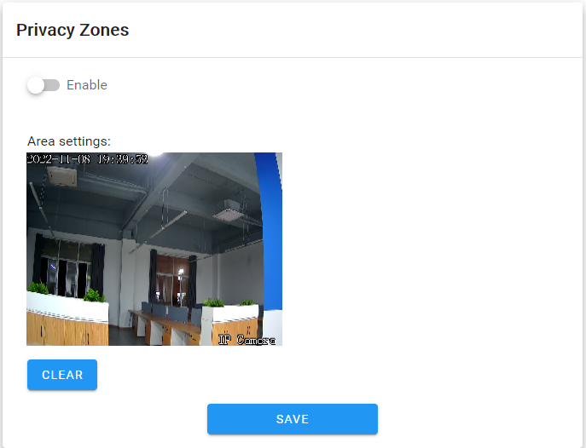
- Enable: privacy masking can be enabled or disabled.
- Setting area: In the preview interface of Setting Area, press and hold the left mouse button and drag to select the area to be masked.
- Clear: click "Clear" to clear the area specified by IPC.

4.10 Human Detection
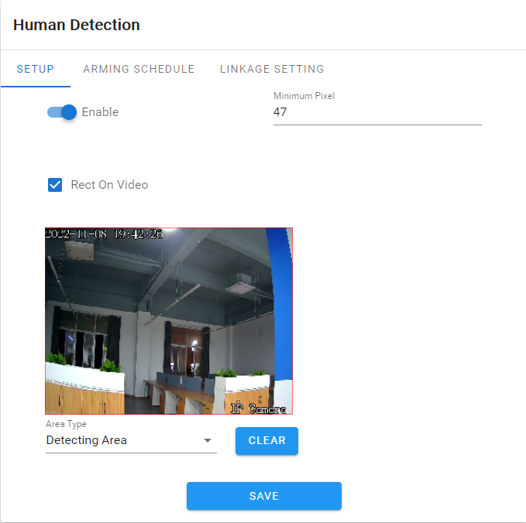
- Parameter setting: you can set whether to enable the human shape detection function; The minimum human shape pixel size can be set to be the minimum human shape pixel size detected; The video stream can be superposed to the human frame; Detection area and shielding area can be set;
- deployment Time: Dyou can set the deployment time from Monday to Sunday;
- Linkage area: linkage upload email, video, FTP, alarm light, alarm output, capture and voice broadcast can be set.

4.11 Video Plan

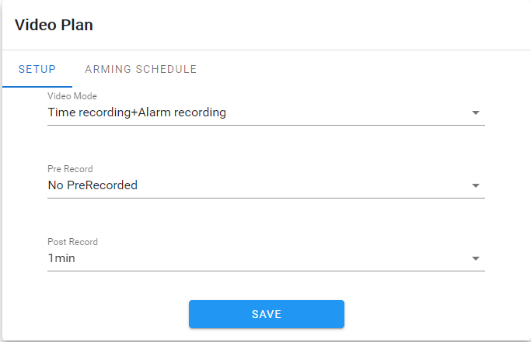
- Parameter configuration: video recording mode, pre recording time and video recording delay can be set;
- Deployment Time: you can set the deployment time from Monday to Sunday;

4.12 Network Settings

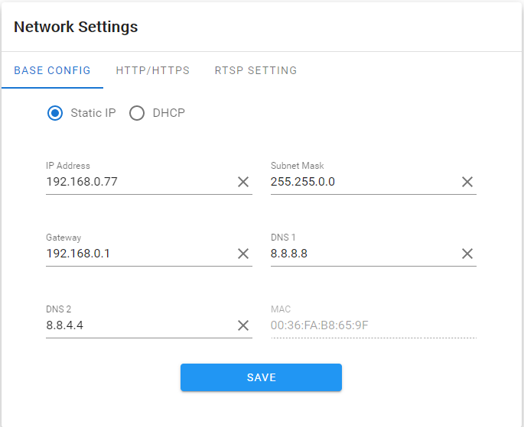
- Basic setting: static IP or DHCP mode can be set;
- HTTP/HTTPS：You can set HTTP or HTTPS access on or off and port number;
- RTSP setting: RTSP on/off, port number, and base64 or Digest authentication mode can be set;

4.13 RTMP Settings
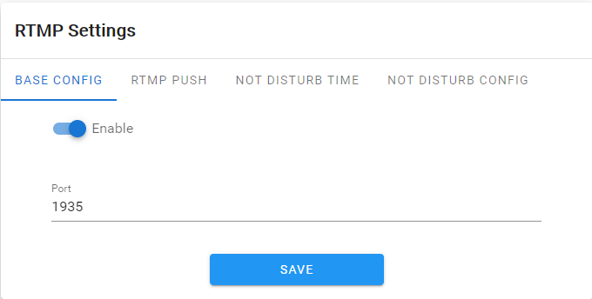

- Basic settings: set whether RTMP is enabled or not and the port number;
- RTMP Push: set whether to display the set rules and detection results in the preview interface;
- No Disturb Time: set the no push time period in weeks;
- No Disturbance Setting: set the no push client;

4.14 Management Platform

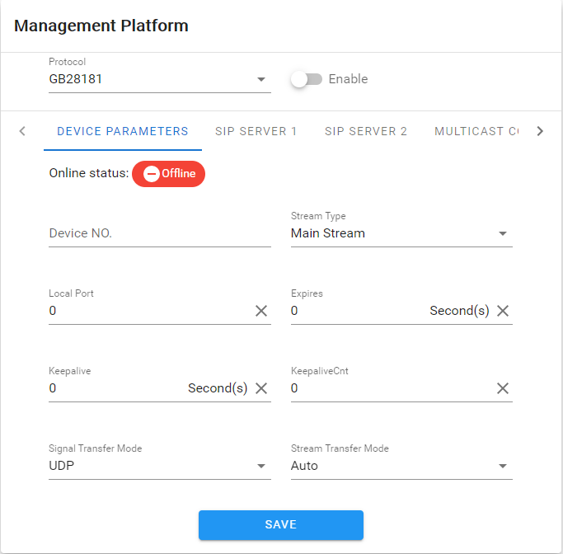

- Equipment parameters: set GB28181 related parameters, including equipment number, code stream type, local port, registration validity period, heartbeat cycle, maximum heartbeat timeout, signaling transmission mode, and stream transmission mode;
- SIP server 1: Set the SIP 1 server number, IP, domain, port, and registration password;
- SIP server 2: Set the SIP 2 server number, IP, domain, port, and registration password;
- Multicast settings: set multicast ports and multicast addresses;
- Channel/alarm: set channel number, alarm level, alarm number and alarm level;

4.15 Multicast Config

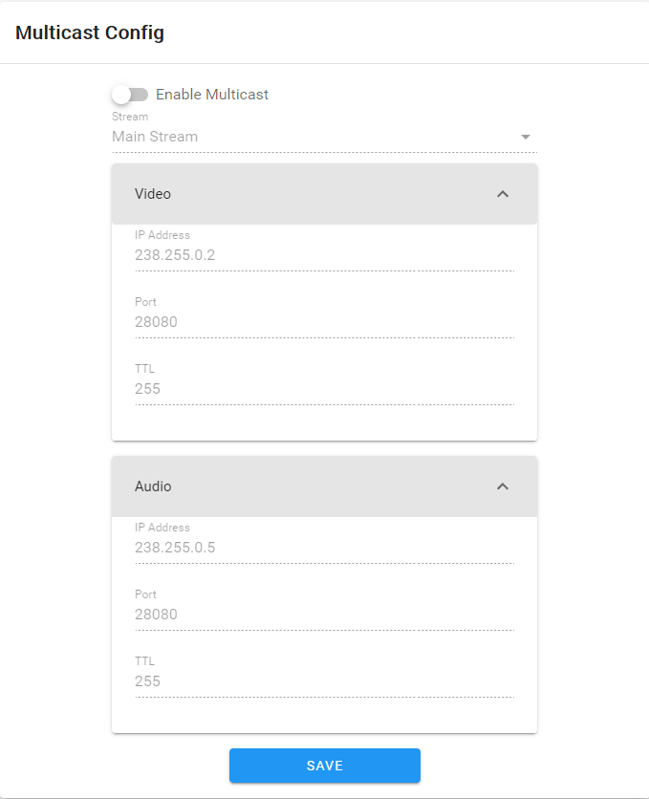

Multicast is disabled by default. After enabling, you can set the IP address, port, and TTL of the multicast main code stream, sub code stream, and audio.

4.16 Email Settings
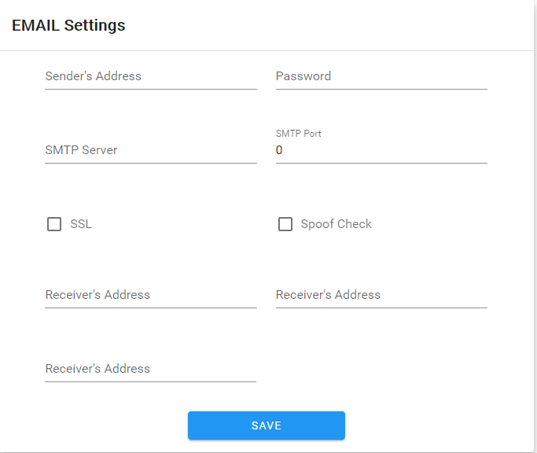

- Sending Email: fill in the email address of the sending box.
- Password: fill in the email password of the outbox.
- confirm Password: Cconfirm the email password.
- SMTP Server: Set the smtp server address of the outgoing mailbox.
- SMTP Port: Set the smtp server port of the outgoing mailbox.
- Receiving mailbox: fill in the address of the receiving mailbox.

4.17 FTP Settings
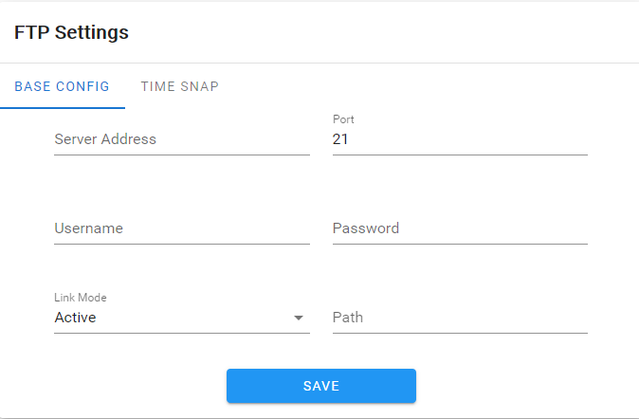
- Basic settings: fill in the server address, port number, user name, password, linkage mode and file path to upload;
- Timing capture: timing capture interval, code stream type and deployment time can be set;

4.18 Alarm Input
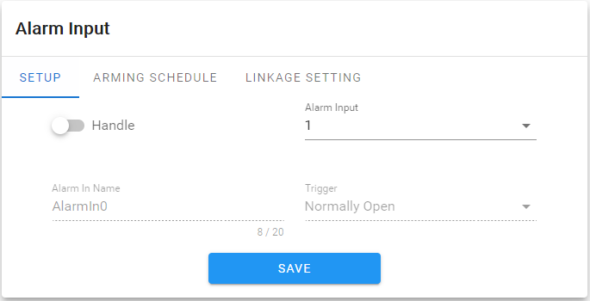

- Parameter configuration: select whether to open alarm input, alarm input terminal, name and trigger level;
- Deployment Time: You can set the deployment time period from Monday to Sunday;
- Linkage setting: you can set the linkage to upload email, video, FTP, alarm light, alarm output, capture, and voice broadcast;

4.19 Alarm Output
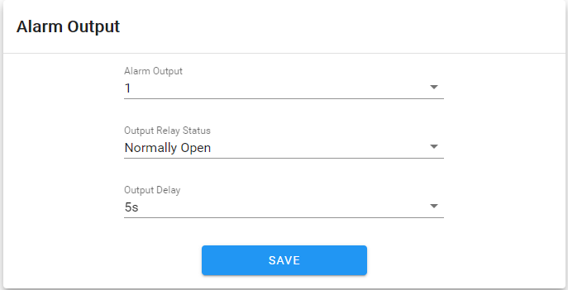
- Alarm output: set alarm output terminal;
- Output relay status: it can be set to normally open and normally closed.
- Output alarm delay: select the delay time of the output alarm (when the alarm triggering ends, the corresponding time of the alarm output delay)

4.20 User Settings

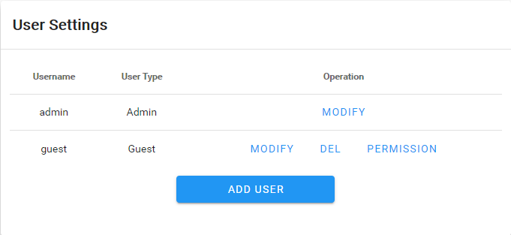

- Modify: login password can be changed for administrator account; Ordinary users can change the user type, set two types: ordinary users and operators, and set different permission assignments in Permission;
- Delete: delete the new user;
- Permission: you can assign permissions to ordinary users;
- Add new users: users can be added as required;

The permissions of the guest user (default) are shown in the following figure:
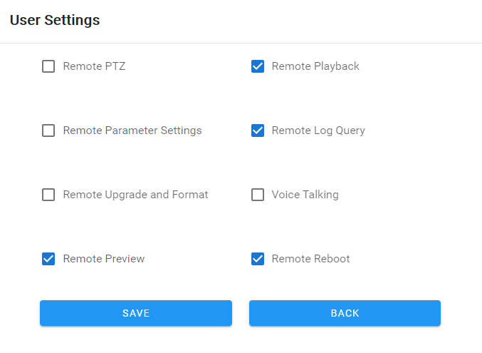

4.21 Storage Management

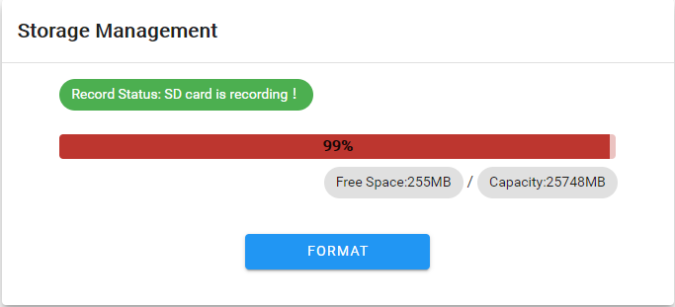

The current recording status can be displayed, the used capacity, remaining capacity and total capacity of SD card can be formatted;

4.22 System Update

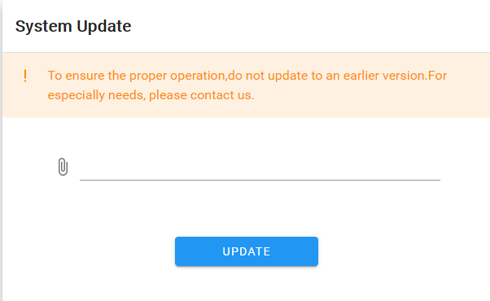
Select the correct upgrade package file and click Upgrade to upgrade the camera;

4.23 Device Maintenance
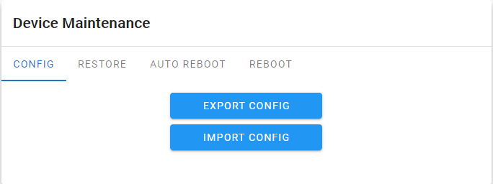
- Configuration: current configuration can be exported and user configuration can be imported;
- Restore default: simple restore or full restore is available;
- Automatic maintenance: automatic maintenance time can be set;
- Restart: restart the camera immediately;

4.24 Developer
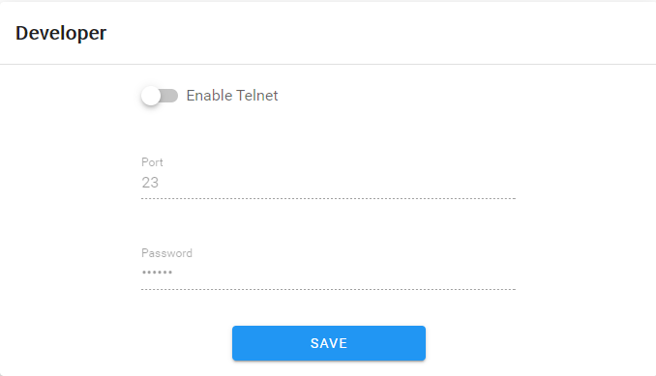

5. File Management
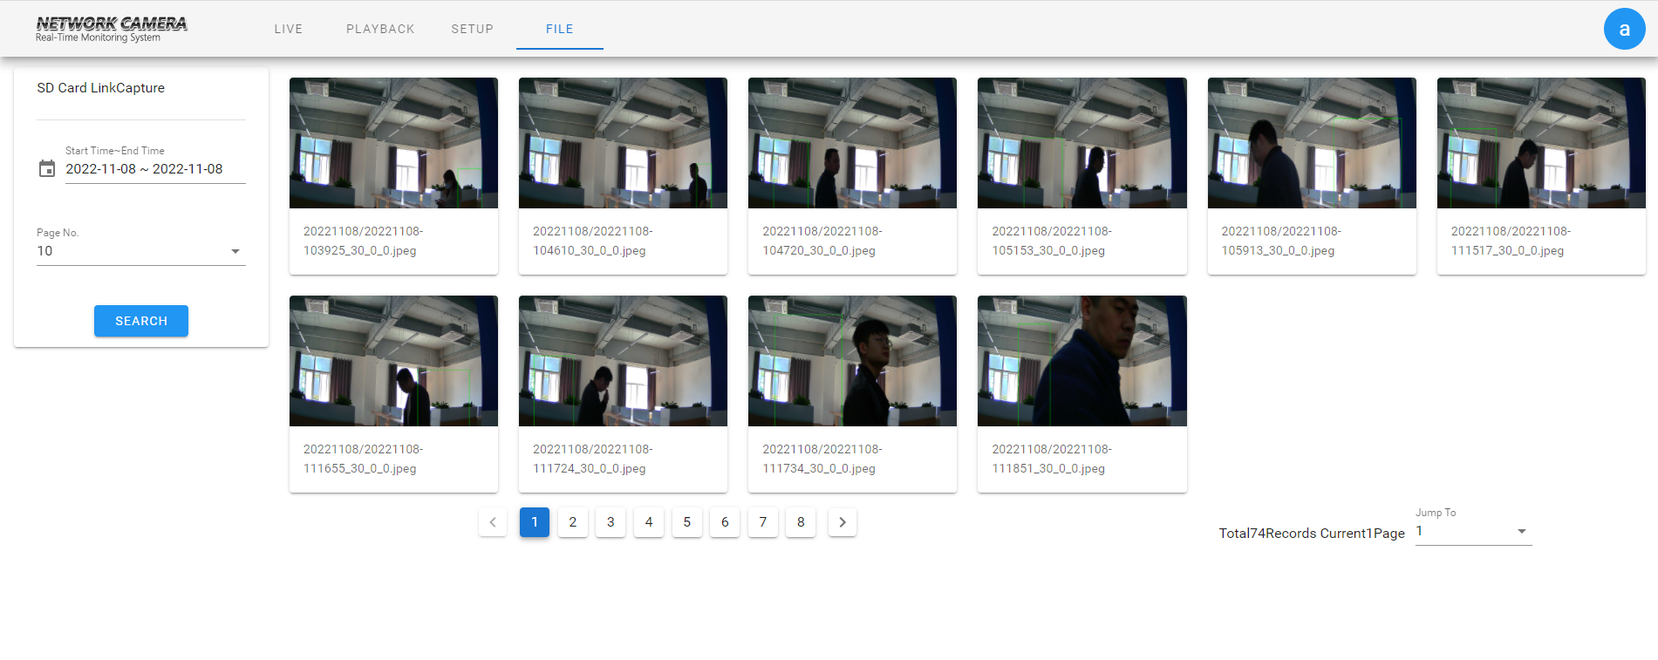
Select the time and click the search button to retrieve the SD card linkage snapshot;

6. Log out

Click the blue letter "a" in the upper right corner to log out, as shown in the figure
